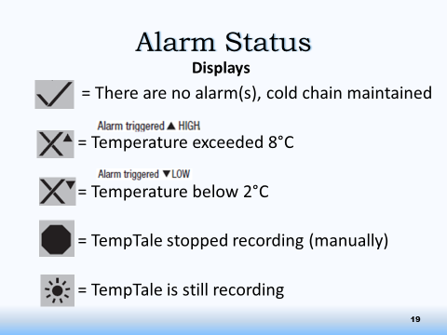
Using TempTales™ (TT) – Vaccine Bags
Standards:
- Place TT in fridge for at least 15 minutes before turning on to ensure TT at Refrigerator temperature.
  - Store TT designated for use in Vaccine Bags in the vaccine fridge whenever they are not in the Vaccine Bags
- TT must be used in the Vaccine Bag whenever there is vaccine in the bag, and they must be monitored regularly while in the bags.
- TT must be handled appropriately to avoid false Alarms
  - Always hold TT by the Rubber Cap to avoid temperature alarm errors.
  - Ensure TTs are never in direct contact with cold/ice packs

There are two options for using the TT in Vaccine Bags:

Option 1: Turn off Between Uses |  | Option 2: Continuous Monitoring
Recommended option for occasional use of Vaccine Bags |  | Recommended option when vaccine bags will be used multiple times per week.
- Pack bag with vaccine and cold/ice packs.  - Turn on TT and immediately place in centre of vaccine.  - At end of clinic:  - Stop TT  - Check Alarm Status  - View Recorded Temperature  - Download Recording  - Clear TT  - Return TT to fridge |  | - Pack bag with vaccine and cold/ice packs.  - Take TT from fridge, date stamp and immediately place in centre of vaccine.  - At end of clinic:  - Leave TT running  - Date stamp TT  - Check Alarm Status  - Store in Fridge until next use.  - Download data once a week.
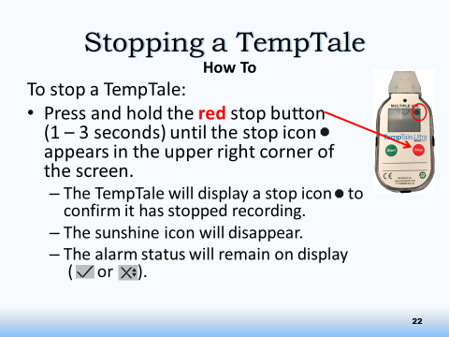
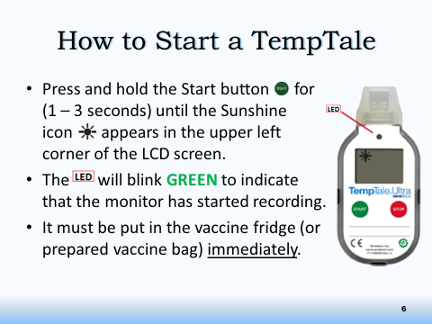

Viewing Recorded Temperatures |  | Date Stamping TT
After turning the TT off, press the Start button to view the recorded temperatures: there will be up to five windows to scroll through:  - Average Temperature  - Minimum recorded temperature  - Maximum recorded temperature  - Total time above high limit  - Total time below low limit |  | Must be used if using Option 2 for Vaccine Bags, or any time a Cold Chain Break has been alarmed.  - While TT is running, press and release the Start button.  - An ↑ icon will appear briefly in top of LCD screen  - “Trip Summary Data” will appear.

