Toolkit for Promoting Influenza Vaccinations in Communities

Objective 1
Planning your influenza messaging campaign 1
Examples of social media messages for different audiences 2
Resources 4
Federal and Provincial Resources 5
Ideas to promote immunizations in your community 5
General Messages that can be shared on social media 6
Messages for addressing myths and misconceptions about influenza immunization: 6
Sample Holiday-Themed Social Media Messages 8
COVID-19 communication resources for community health and safety 11

Objective
Recognizing the challenges of promoting influenza vaccinations in Alberta’s First Nations communities, this guide includes resources for health care providers supporting the Influenza immunization program. This toolkit was developed to assist health care providers in:

- Planning campaign messages;
- Locating influenza promotion resources and;
- Providing examples to assist in delivering messaging about vaccinations;
- Providing ideas to promote immunization in communities;
- Providing general messaging to share on social media pages.

Most First Nations in Alberta are active on social media with Facebook as the primary platform. The advice outlined in this document largely focuses on the use of social media to raise awareness about influenza vaccinations.

Planning your influenza messaging campaign
Consider tailoring your messages for particular audiences. Elders and seniors, parents, individuals who have chronic conditions such as diabetes or asthma may respond to messages tailored for them.

Consider the frequency of messages. Generally, messages need to be repeated for people to recognize and then act on the message. Consider posting information about vaccination more than once and with different variations on the theme of the message.

Consider the timing of the message. Messages can have a stronger impact when it is associated to an event or a limited period of time eg. upcoming or recent vaccination drive, back-to-school preparation or peak flu season.

Consider who is the spokesperson for the message. First Nations leadership, trusted Elders, or health staff such as doctors or nurses are examples of trusted sources of information in communities.

Ultimately, your own experience in your community with help guide you as you decide how best to plan your campaign, but keep in mind: the audience, the spokesperson, the message, timing and the delivery platform.

Addressing Different Audiences – the following section highlights different communication tools that can be used to target different audiences.

Health care professionals play an essential role in providing the public with evidence-based information regarding immunization. Different methods of communication are going to be more effective for different target audiences. Identify your at-risk and eligible patients and remind them about the importance of their annual influenza vaccination. Different target audiences may include families, children, people with higher risk conditions, schools, parents, and adults over 65.

When planning your influenza campaign, consider the social media channel and messaging you decide to use to target certain age groups. For example, social media channels such as Tik Tok and Instagram are very effective for younger age groups, whereas Facebook is more useful for reaching an older demographic.

Examples of social media messages for different audiences
This is not an exhaustive list, but more to demonstrate the diversity of messages and how other organizations tailor their messages to particular audiences.

Note for Elders |  | Note for seniors with a testimonial
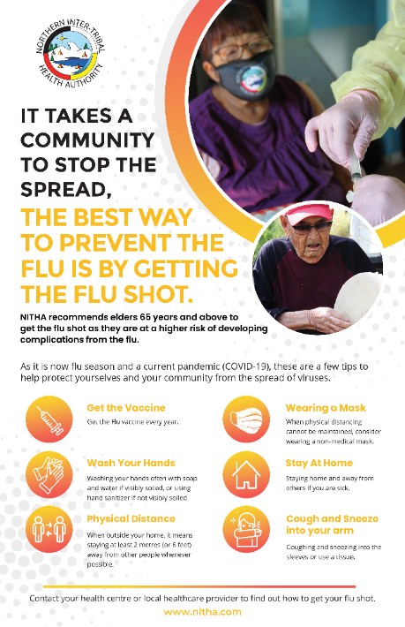 |  | 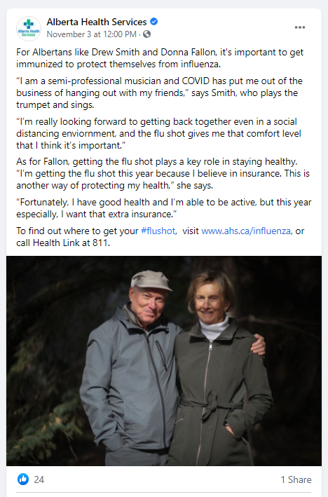
Protecting others by getting vaccinated | Educating about vaccinations
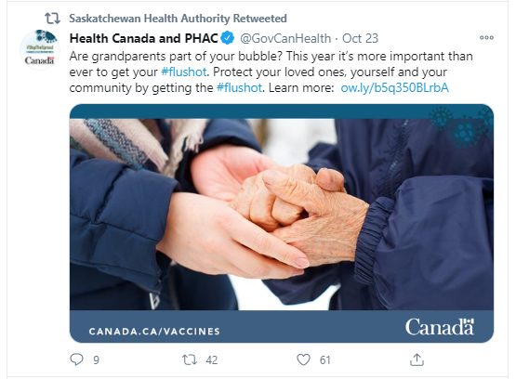 | 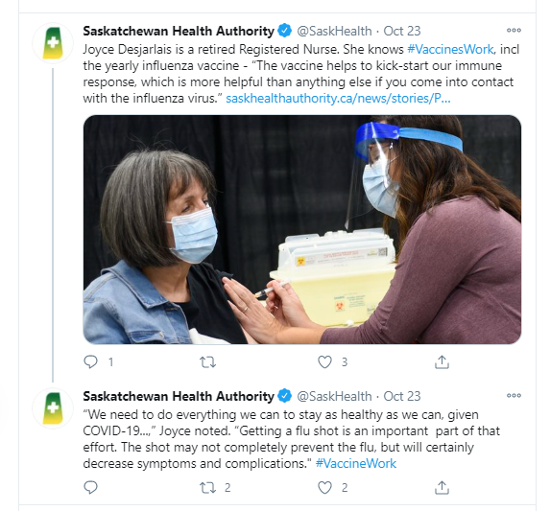
Community Notices | Community Notices
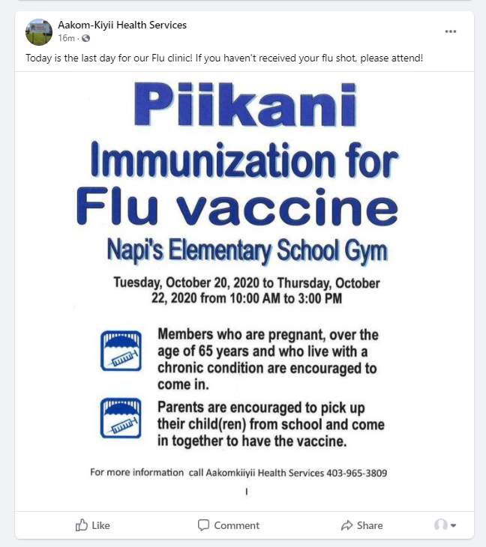 | 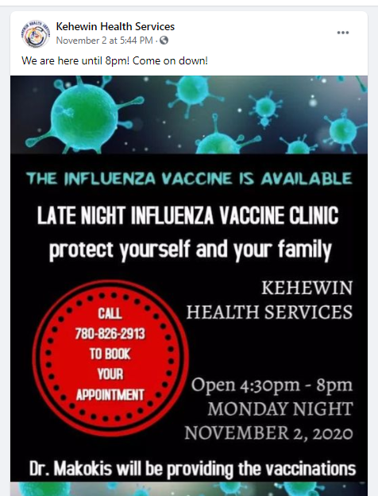

Leadership supporting influenza vaccination – video and Facebook post – former Grand Chief Morin  https://www.facebook.com/2198326743754753/videos/3409690139086908 | Video - Keewatinohk Inniniw Minoayawin  https://www.youtube.com/watch?v=byWa7neqogY&feature=emb_logo  Although this video is for a Manitoba audience it could be shared on social media with local information as part of the text of the post.
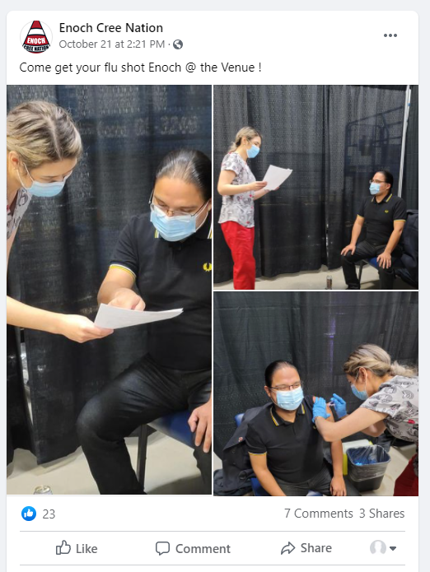 | 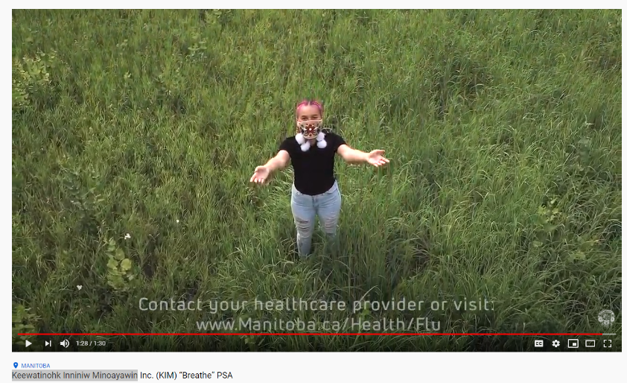

Resources
Campaign planning ideas
https://www.ecdc.europa.eu/en/publications-data/communication-guidelines-influenza-vaccination
https://www.cdc.gov/flu/pdf/partners/nivdp-tip-sheet.pdf

Indigenous developed influenza resources – posters, videos, radio scripts that could be used as a template and customized for your community.

First Nations Health Authority – British Columbia
https://www.fnha.ca/what-we-do/communicable-disease-control/influenza-information

Northern Inter-Tribal Health Authority – Saskatchewan
http://www.nitha.com/public-health/
Pamphlet – How to Fight the Flu (NITHA)

Federal and Provincial Resources
Indigenous Services Canada – Influenza Resources
https://www.sac-isc.gc.ca/eng/1570037443226/1570037485313

Public Health Agency of Canada – Influenza Resources
https://www.canada.ca/en/public-health/services/diseases/flu-influenza/flu-influenza-awareness-resources.html

Alberta Health Services – Influenza Resources and information
https://www.albertahealthservices.ca/influenza/Page12453.aspx
https://www.albertahealthservices.ca/influenza/influenza.aspx

Ideas to promote immunizations in your community
- Consider promoting local campaigns through social media. ISC Communications can provide support in the development of posters and other materials that can be customized for each community . Please find an example of a social media poster in support of a local vaccination campaign in 2021.
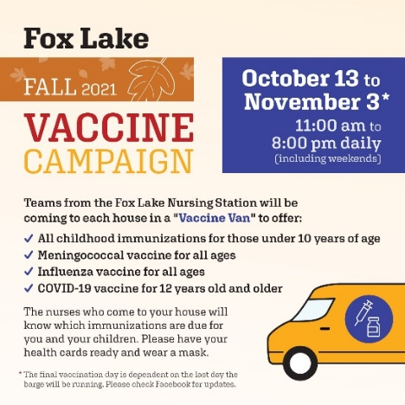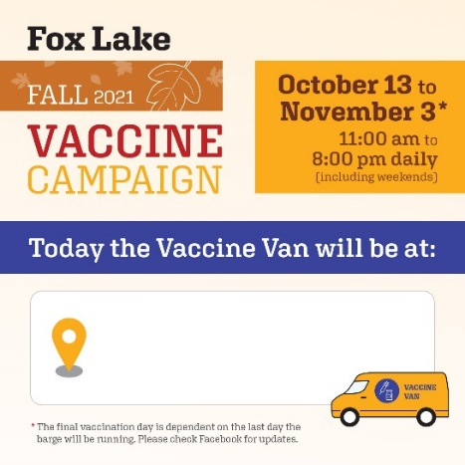
- Use social media to share messages about the impact of the flu in addition to your local flu immunization messages. Typically, one or two messages a day for a week in advance of a major flu immunization clinic or event should raise awareness of the event.
- Cross promote immunizations at other health care information sharing events such as: diabetes classes, pre-natal classes and chronic disease clinics, ensuring all COVID-19 prevention programs are being followed. Physicians, nurses and other health care professionals should be encouraged to advise patients to consider getting the flu vaccination when they are meeting with patients.
- Spearhead a “pledge” to encourage people to get the vaccine. A pledge, increases a person's likelihood of taking action, especially when the commitment is made publicly. Furthermore, public pledges also convey the message that vaccination is a social norm and something to celebrate.
- Engage with community leadership and ask them to be ambassadors for flu vaccinations by sharing their message on social media. This is an example of former Grand Chief Morin sharing his flu message on Facebook: https://www.facebook.com/2198326743754753/videos/3409690139086908
- Identify individuals who have contracted the flu and recovered and approach them to speak about how the illness affected their lives. This could be a short note with a photo or a short video shared on social media, of the individual talking about their experience.
- Share personal experiences about getting vaccinated. Research shows that storytelling is a highly engaging form of communication. Many people won’t remember a statistic, but they will remember a story.
General Messages that can be shared on social media
The messages below can be formatted into a social media post. Consider including an image or short video with the message, as these posts often get more views.

- Vaccines work. They are the most effective way to prevent diseases like influenza and COVID-19 that can cause serious illness, hospitalization, and death.
- Influenza can spread easily and quickly to anyone, even before you know you are sick. Indigenous people with chronic health conditions or living in overcrowded homes are at a higher risk of hospitalization and serious health complications from influenza. Getting the flu shot can help keep you and your community healthy.
- Young children, people over age 65, pregnant women and those who are in poor health are more likely to become very sick from influenza. Getting the flu shot can help protect you and your family from influenza.
- It’s easy for us to spread influenza virus without knowing. Even if we’re otherwise healthy, we can still get influenza and spread it to the people we care for. Help protect yourself and others with by getting vaccinated.

- If you have diabetes, have a compromised immune system or have lung, heart, kidney, liver or respiratory conditions, you are more likely to experience serious complications from influenza. Contact your local health care service provider for information on getting the flu shot.

Messages for addressing myths and misconceptions about influenza immunization:
Myth 1: Influenza is not serious so I don’t need the vaccine
- Fact: Everyone who can get the flu shot should get vaccinated. You can be infected with influenza and spread it, even if you're not showing symptoms. Getting the vaccine means you can also help protect others from getting sick, especially those who have medical conditions or infants too young to get immunized who are more likely to have complications from getting the flu. We want to protect those who cannot get the vaccine.

Myth 2: The flu vaccine can give me the flu
- Fact: The flu shot is safe. You cannot get the influenza virus from the flu shot. Most people do not have significant side effects from the flu shot. Serious side effects are extremely rare. If you have concerns or questions about the flu shot, talk to your nurse or doctor.

Myth 3: I had the vaccine and still got the flu, so it doesn’t work
- Fact: Every year, the World Health Organization recommends protecting against a handful of influenza strains they think will be the most common. Vaccines are then developed to protect against these specific strains. Sometimes, it’s not a perfect match and an influenza strain not planned for in the current vaccine begins to circulate, which is why people may still get the flu despite being vaccinated. Despite all this, vaccines is still the best way to protect yourself from getting the flu, especially if you have a compromised immune system.

Myth 4: I am pregnant so shouldn’t get the flu vaccine
- Fact: Pregnant women should especially get the flu vaccine since their immune systems are weaker than usual. The inactivated flu vaccine is safe at any stage of pregnancy.

Myth 5: I got the COVID vaccine, so I don’t need to get the flu vaccine
- Fact: Influenza and COVID-19 are caused by different viruses so each virus has it’s own vaccine. You need to be vaccinated for both to be protected against both. The good news is that you can get the two different vaccines at the same time.

Sample Radio Script – this script could be used for a health professional to record a message for local radio, or they could record a cellphone video using this script and it could be shared on social media.

Hello Everyone, it is {Name} I just want to remind you that it is influenza and pneumonia vaccination time of year again. Every year I encourage as many people as possible to get vaccinated, but this year with COVID-19 present it is more important than ever to protect yourself and your family from influenza and pneumonia.
Seniors, Elders, people with lung conditions and children over the age of six months should all be vaccinated as these groups are considered high risk. However, this year, especially because of COVID-19, EVERYONE eligible should get the flu and pneumonia shots too.
- Getting vaccinated can reduce the chance of people getting influenza or pneumonia.
- Getting vaccinated reduces the chance that the healthcare system could become overwhelmed by patients with influenza, pneumonia and COVID at the same time
- Getting vaccinated could potentially help reduce unnecessary testing for respiratory viruses, like COVID-19 and influenza.
- Getting children vaccinated is important for their safety and the safety of others, as children are often “super-spreaders” of the flu.
Please contact your local health care provider to find out how to get this year’s influenza and pneumonia vaccinations.
Get the shots and reduce you and your family’s risk of getting influenza and pneumonia.

Sample Holiday-Themed Social Media Messages

Facebook
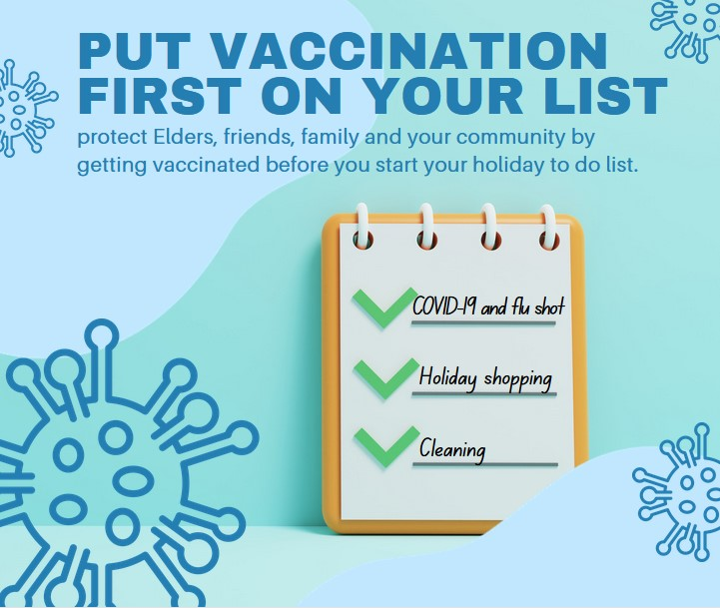

Instagram
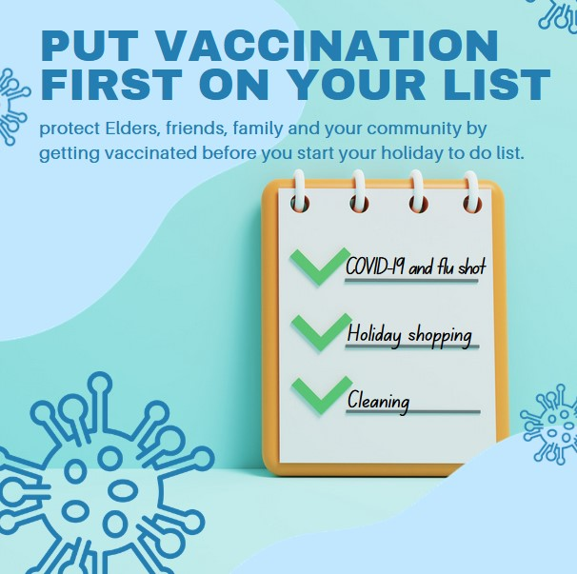

Sample text for social media post:
Before you make your list and check it twice, put vaccination at the top of your holiday to do list! [Insert relevant hashtags here e.g. #GetVaccinated #ProtectOurElders]

Facebook
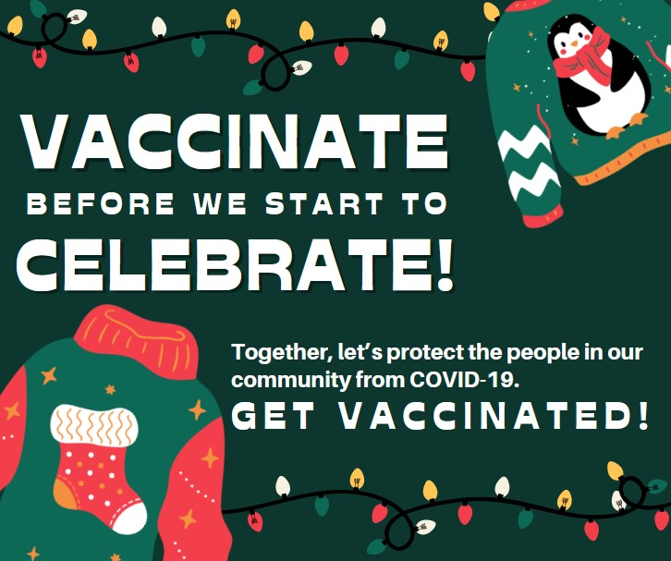

Instagram
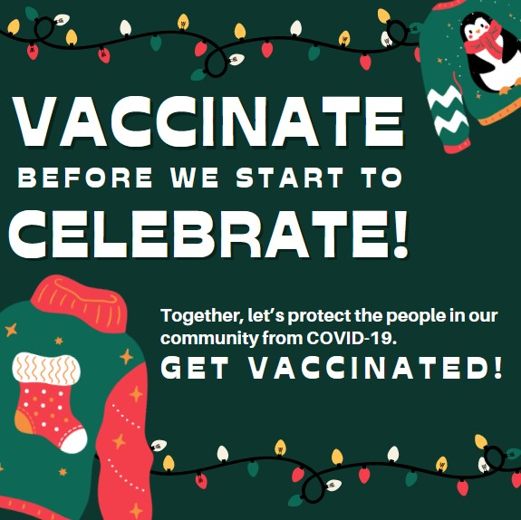

Sample text for social media post:
The holiday season is a time we do a lot of visiting and getting together with family and friends whether it’s Winter Solstice, Christmas or the New Year, so now is the time to make sure your family is up to date with flu and COVID-19 vaccinations. [Insert relevant hashtags here e.g. #GetVaccinated #ProtectOurElders]

Facebook
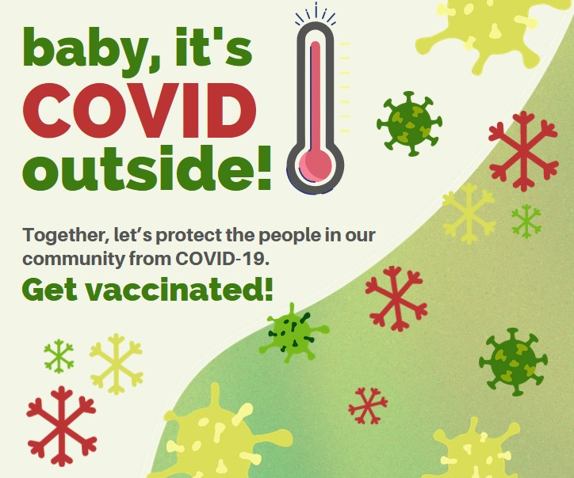

Instagram
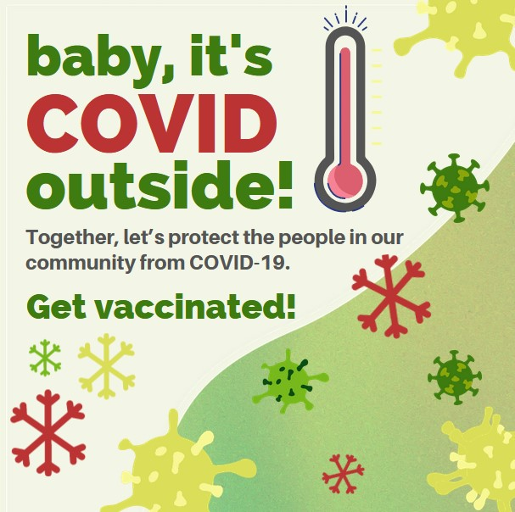

Sample text for social media post:
Everyone in Alberta aged 6 months and older is eligible to be vaccinated against COVID-19. Vaccination is a vital tool to reduce the harm COVID causes in our communities. [Insert relevant hashtags here e.g. #GetVaccinated #ProtectOurElders]

COVID-19 communication resources for community health and safety

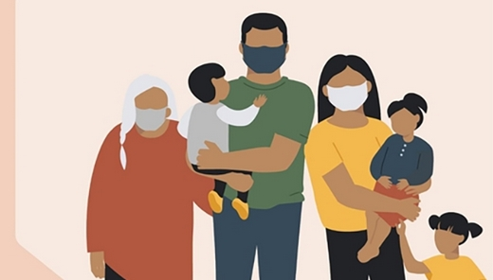
Indigenous Services Canada maintains a webpage that provides communications resources on topics related to community health and safety that can be shared with or adapted to your community. Please find the link below:

COVID-19 communication resources for community health and safety (sac-isc.gc.ca)

The advice and examples provided in the webpage have been developed with the understanding that each community is unique in the way it shares information with its members. Communities are encouraged to adapt the messages and strategies to meet the needs of their members.

Resources include:
- About the resources
- Emergency communications resources
- Mental wellness resources
- Vaccines (including pediatric vaccines)
- COVID-19 variants and conditions
- Public service announcements for community use
- Travel
- Respecting personal choice
- Public health measures
- Resources for parents

Awareness resources created by Indigenous organizations, Indigenous Services Canada and other government departments.

These awareness resources were created for Indigenous communities by the Public Health Agency of Canada, Indigenous Services Canada and various Indigenous organizations.

Some of the resources are available in a variety of Indigenous languages and can be found in the below links:

- Awareness resources and videos
- In Plains Cree: Coronavirus âhkosiwin (COVID-19): Aswêyihtamowin âpacihcikana
- In Eastern Ojibwe: Corono manijooshens aakoziwin (COVID-19): Gikendamowin nikaaziwinan

