### Insulated Vaccine Bags

**Standard:**

Insulated Vaccine bags are to be used whenever vaccine is away from Vaccine refrigerator, including during clinics.

*Reminder – vaccine refrigerator door should not be opened more than 4 times per day.*

Insulated Vaccine Bags are soft-sided zipped units designed to maintain vaccine between 2 and 8 0C while the vaccine is away from the vaccine refrigerator. Two sizes are available through the Drug Distribution Centre (DDC).

Bags must be completely intact (i.e. zippers fully close, no tears) to maintain temperatures. If there is a thermometer that comes with the bag, it is to be used as an alert only: given the location of where the pouch that holds this thermometer is there are many factors that can impact the temperature reading.

Sufficient cold/frozen packs are required to enable proper use of vaccine bags.

There should be enough vaccine bags for regular clinics, off-site clinics, use by other programs – i.e. Home Care – and for storing vaccine should there be a power outage.

#### Packing Vaccine Bags

|  |  |
| --- | --- |
|  | Vaccine Bag |
|  | Frozen Pack |
|  | Fridge temperature pack (Cold Pack) |
|  | Vaccine |
|  | TagAlert or other indicator |
|  | Filler (paper, bubble pack, etc.) |

When using the insulated vaccine bags, please follow these guidelines:

1. Bags must be intact: they should be replaced every two years or if damaged.
2. All cold and frozen packs need to be “charged/conditioned” for at least 24 hours before and between uses.
3. Vaccine needs to be kept in the centre and completely surrounded by cold packs. (i.e. 6 sides)
   1. Guidance:
      1. vaccine away from fridge for up to 4 hours: use of cold packs alone should be sufficient to maintain temperature.
      2. vaccine away from the fridge for more than 4 hours: use of frozen packs placed on the top and possibly the bottom of the bags in addition to the cold packs.
4. Allow frozen packs to “sweat” – i.e. sit on counter for at least 15 minutes prior to placing in bags. Frozen packs are on the outside perimeter (top and bottom), with cold packs immediately next to them and between the vaccine and ice packs.
5. Use bubble wrap, professional towels, etc., between the vaccine and the cold packs to fill dead space and minimize risk for exposing vaccine to temperature extremes.
6. Use TempTales® in middle with vaccines to monitor temperature.
7. Keep zipper closed. During clinic, with appropriate packing of the vaccine bag - if zipper is mostly closed and the lid is down, temperatures will be maintained for 4 hours.

#### Step by Step packing pictures

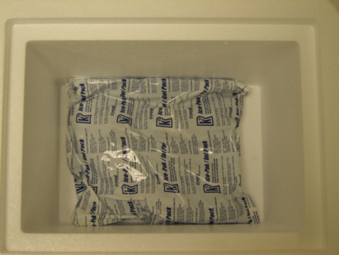 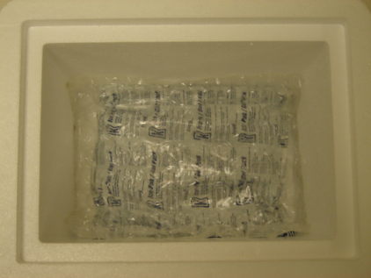 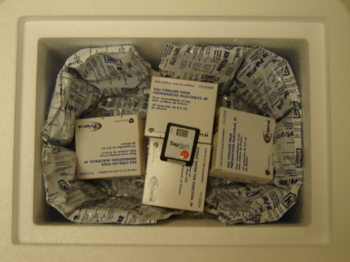



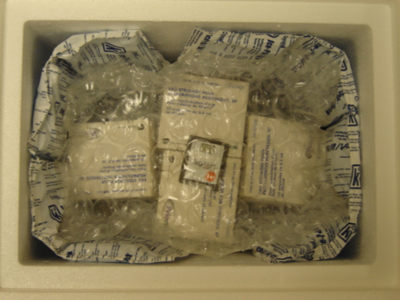 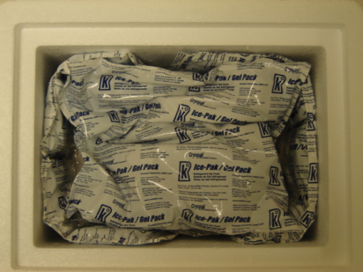 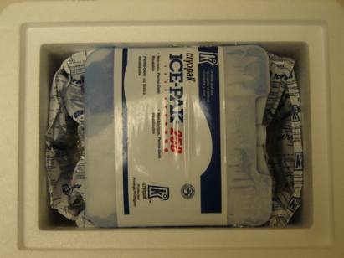

*Extract from FNIHB AB Region Vaccine Management Package*