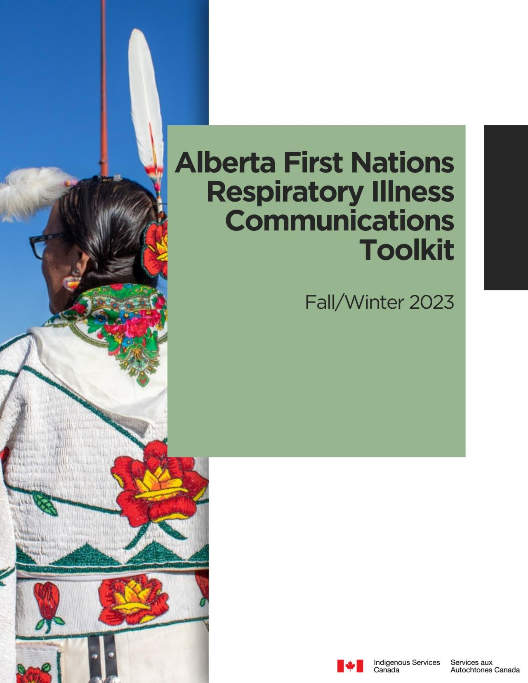

TOOLKIT FOR FALL/WINTER RESPIRATORY ILLNESS MESSAGING IN COMMUNITIES

INTRODUCTION

As we move into the colder months, illnesses like influenza, COVID 19 and other respiratory viruses spread quickly and easily. Recognizing the challenges of promoting public health awareness and respiratory virus immunizations in Alberta First Nations communities, this guide is intended for health care providers and Indigenous communities to assist in creating a public health campaign for the fall and winter. This toolkit was developed to assist in:

- Planning campaign messages
- Locating
informational resources for common respiratory illnesses
- Providing examples to assist in delivering messaging
- Providing ideas to promote immunization in communities
- Providing general messaging to
share on social media pages

Table of Contents

Planning Your Immunization Campaign 3
Addressing Different Audiences 4
Sample Social Media Messages 5
Ideas To Promote Immunizations In Your Community 8
Resources For Fall And Winter Immunization 10
Key Messages 13
Sample Radio And Video Scripts 14

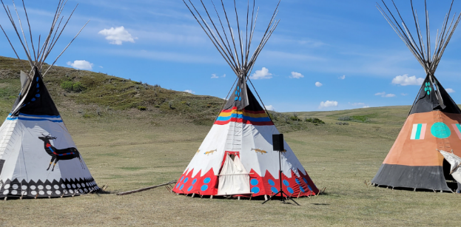

PLANNING YOUR IMMUNIZATION CAMPAIGN

Target audience:
Consider tailoring your messages for particular audiences. Elders and seniors, parents, pregnant individuals, individuals who have chronic conditions such as diabetes or asthma may respond to messages tailored for them.

Message frequency:
Consider the frequency of messages. Generally, messages need to be repeated for people to recognize and then act on the message. Consider posting information more than once and with different variations on the theme of the message.

Message timing:
Consider the timing of the message. Messages can have a stronger impact when it is associated to an event or a limited period of time e.g. upcoming family holiday, cultural event or peak influenza season.

Spokespersons:
Consider who the spokesperson is for the message. First Nations leadership, trusted Elders, or health staff such as doctors or nurses are examples of people who are often seen as trusted sources of information in communities.

Ultimately, your own community experience will help guide you as you decide how best to plan your campaign, but in addition to the message or information that needs to be shared, please keep in mind: the audience, the spokesperson, the message, timing and the delivery platform.

ADDRESSING DIFFERENT AUDIENCES

The following section highlights different communication tools that can be used to target different audiences.

Health care professionals play an essential role in providing the public with evidence-based information regarding immunization. Different methods of communication are going to be more effective for different target audiences. Identify your at-risk and eligible patients and remind them about health conditions common in the fall and winter and importance of their seasonal and annual vaccinations. Different target audiences may include families, children, people with higher risk conditions, schools, parents, and adults over 65.

For example, social media channels such as Tik Tok and Instagram are very effective for younger age groups, whereas Facebook is more useful for reaching an older demographic.

When planning your campaign, consider the social media channel and messaging you decide to use to target certain age groups.

SAMPLE SOCIAL MEDIA MESSAGES
Examples of social media  messages for different audiences.  Click on the title to see the original post. |  | This is not an exhaustive list, but demonstrates the diversity of messages and how organizations tailor their messages to particular audiences.
Note for Elders  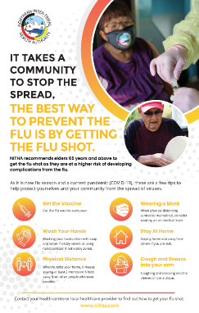 |  | Note for seniors with a testimonial  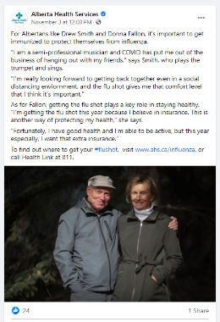
Protecting others by getting vaccinated  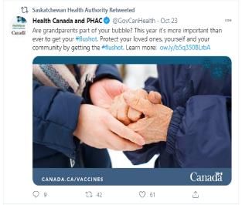 |  | Educating about influenza, COVID-19 & routine vaccinations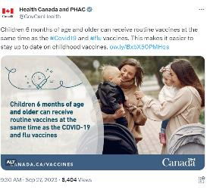
Messages from leadership and health officials
Using community leaders or official social media accounts can broaden the reach and increase the level of trust in the messaging.

Blood Tribe Department of Health  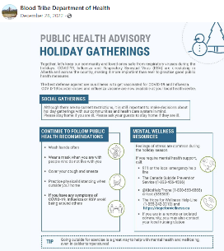 |  | Blood Tribe Department of Health  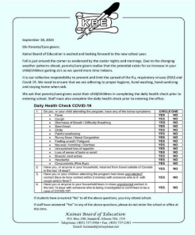
Siksika Health Services  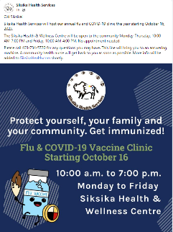 |  | Enoch Cree Nation  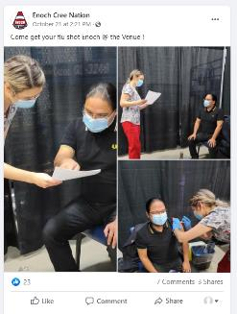

Reposting messages from government health officials
Using community leaders or official social media accounts can broaden the reach and increase the level of trust in the messages.

Indigenous Services Canada
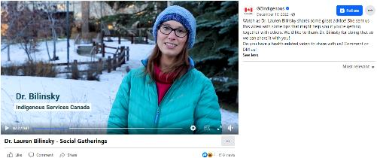
Alberta Health Services
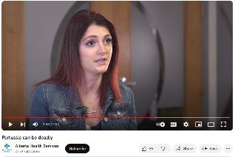

IDEAS TO PROMOTE IMMUNIZATIONS IN YOUR COMMUNITY

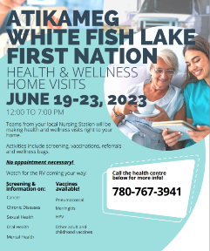
Local campaigns
Consider promoting local campaigns through social media.
The Indigenous Services Canada Alberta Region Communications Team can provide support in the development of posters and other materials that can be customized for each community. To the right, please find an example of a social media poster in support of a local vaccination campaign in 2023.

Timing of social media
Typically, one or two social media messages a day for a week in advance of a major immunization clinic or event can raise awareness of the event.

Cross promotion
Cross promote immunization opportunities at other health care information sharing events such as: diabetes classes, pre-natal classes and chronic disease clinics. Physicians, nurses and other health care professionals should advise patients to consider getting vaccinated when meeting with patients.

Pledge campaign
Spearhead a “pledge” to encourage people to get the vaccine. A pledge can increase a person's likelihood of taking action, especially when the commitment is made publicly.

Identify ambassadors
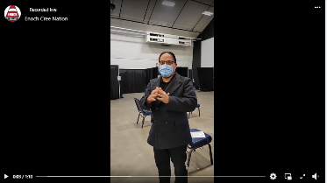
Engage with community leadership and ask them to be ambassadors for seasonal and routine vaccinations by sharing their message on social media. For example, in 2020, Chief Morin shared his flu message in a Facebook post.

Share personal stories
Identify individuals who have contracted respiratory illnesses and recovered. Ask them to speak about how the illness affected their lives. This could be a short note with a photo or a short video shared on social media, where the individual talks about their experience.

Research shows that storytelling is a highly engaging form of communication. Many people won’t remember a statistic, but they will remember a story.

RESOURCES FOR FALL AND WINTER IMMUNIZATION
Please use these resources and customize to suit your needs and target audience or simply re-share directly on your social media accounts.

COVID-19

- Indigenous Services Canada
  - COVID-19 communication resources for community health and safety (sac-isc.gc.ca)
    - Mental Wellness
    - Vaccines
    - Variants and conditions
    - Respecting personal choice
    - Resources for parents
    - public service announcement scripts

  - Available in a variety of Indigenous languages
    - Awareness resources and videos
    - Resources in Plains Cree
    - Resources in Eastern Ojibwe

Influenza

- Unbranded resources customizable through a free Canva account
(Many thanks to the Northern Inter-Tribal Health Authority for granting permission and sharing the below resources)

Instagram poster
Facebook poster
Facebook poster v.2
Infographic print poster
To customize the social media resources for your community, create a free Canva account and follow the below instructions:
Open link. Select ‘File’ and click ‘Make a copy’.
Customize the resource with your community’s branding or any additional information that may be needed.
Once complete select ‘Share’ and click ‘Download’.

- Indigenous Services Canada
  - Audio PSA from Dr. Chris Sarin – Fall 2023
  - Video PSA from Dr. Lauren Bilinsky – Fall 2023
  - PDF influenza factsheet
  - PDF for families
  - PDF for seniors
- Public Health Agency of Canada
  - Influenza Resources

- Alberta Health Services/Alberta Health
  - How to be an influenza champion
  - Cover Your Cough poster – Clinics and Offices

- First Nations Health Authority (British Columbia)
  - Fewer Face, Wide-Open Spaces - A guide to gatherings and events during respiratory influenza and COVID-19 season.
  - Feeling Sick? Stay Home. - Infographic
  - My Wellness Checklist - Postcard

Whooping cough

- Indigenous Services Canada
  - Audio PSA from Dr. Lauren Bilinsky – Fall 2023
  - Video PSA from Dr. Lauren Bilinsky – Fall 2023

- Health Canada
  - Pertussis (whooping cough) - Canada.ca
  - Pertussis (whooping cough): For health professionals

- Public Health Agency of Canada
  - Pertussis (whooping cough) still a danger to infants - Infographic - Canada.ca

- Immunize Canada
  - Pertussis (Whooping Cough) | immunizecanada

- Alberta Health Services/Alberta Health
  - dTap Immunization in Pregnancy Poster (albertahealthservices.ca)
  - Pertussis (whooping cough) (alberta.ca)
  - Whooping Cough (Pertussis) (alberta.ca)
  - Pertussis Outbreak | Alberta Health Services
  - Pertussis can be deadly - YouTube

Respiratory Illnesses

- Indigenous Services Canada
  - Audio PSA from Dr. Sarin 2023

- Alberta Health Services/Alberta Health
  - Respiratory Illness Comparison Chart

- First Nation Health Authority (British Columbia)
  - Feeling sick? ​Stop the spread
  - Respiratory Virus Season: Making Healthy Decisions​
  - My Wellness Checklist​
  - Fewer Face, Wide-Open Spaces

Outdoor Health

- Health Canada
  - Extreme Cold
  - Your Health Outdoors – What You Can Do During Fall and Winter

- Environment Canada
  - Wind Chill factsheet

- Alberta Health Services/Alberta Health
  - Working in extreme cold

Group A Strep

Northern Inter-Tribal Health Authority resources
- Invasive Group A Streptococcus (IGAS) Fact Sheet
- Impetigo Fact Sheet

Routine Immunizations

Public Health Agency of Canada
- Promotional resources
- Infographic: Vaccines work

Immunize Canada
- Promotional resources

Campaign planning ideas

  - European Centre for Disease Prevention and Control
  - Centers for Disease Control and Prevention
 | KEY MESSAGES  - Vaccines work. They are the most effective way to prevent diseases that can cause serious illness, hospitalization, and death.  - Influenza can spread easily and quickly to anyone, even before you know you are sick. People with chronic health conditions or living in overcrowded homes are at a higher risk of hospitalization and serious health complications from influenza. Getting the influenza vaccine can help keep you and your community healthy.  - Young children, people over age 65, pregnant women and those who are in poor health are more likely to become very sick from influenza. The flu shot can help protect you and your family from serious illness.  - It’s easy for us to pass the influenza virus on without knowing. Even if we’re healthy, we can still get influenza and spread it to the people we care about. Help protect yourself and others by getting the influenza vaccine.  - People who are pregnant are at higher risk of severe COVID-19 complications. The National Advisory Committee on Immunization (NACI) recommends pregnant people to get the vaccine at any time during pregnancy if they are eligible as there has been no safety signals detected during pregnancy.  - The National Advisory Committee on Immunization (NACI) recommends that for children 5 and older, the influenza vaccine is safe to receive at the same time as any other vaccines, including COVID-19 and routine childhood vaccinations..  - If you have diabetes, a compromised immune system or have lung, heart, kidney, liver disease you are more likely to experience serious complications from influenza Those most at risk are encouraged to get their influenza vaccination. |  | These messages can be formatted into a social media post. Consider including an image or short video with the message, as these posts often get more views.
 |  |  | 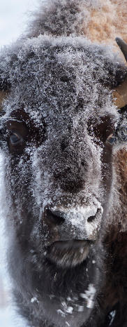

SAMPLE RADIO AND VIDEO SCRIPTS
These scripts could be used for a health professional to record a message for local radio, or they could record a cellphone video using this script and it could be shared on social media.

Getting Vaccinated #1
Hello Everyone, it is {Name} I just want to remind you that it is influenza and COVID-19 vaccination time of year again. Every year I encourage as many people as possible to get vaccinated, but this year with both influenza and COVID-19 present it is more important than ever to protect yourself and your family from influenza and COVID-19.

Seniors, Elders, people with lung conditions and children over the age of six months should all be vaccinated as these groups are considered high risk. However, everyone eligible should get the flu and COVID-19 vaccination.
- Getting vaccinated can reduce the chance of getting influenza and COVID-19 and chances of spreading it to others.
- Getting vaccinated reduces the chance that the healthcare system could become overwhelmed by avoiding treatment for influenza and COVID-19 patients at the same time.
- Getting vaccinated could help reduce unnecessary testing for COVID-19 and other respiratory conditions as symptoms for them are similar.
- Getting children vaccinated is important for their safety and the safety of others, as children are often in contact with many people in school or daycare and so can easily spread viruses such as influenza.

Please contact your local health care provider to find out how to get this year’s influenza and COVID-19 vaccinations.

Get the vaccinations and reduce you and your family’s risk from serious illness.
Getting Vaccinated #2
As we get into the colder months, we see illnesses like influenza and COVID-19 spreading easily and quickly.

A simple way to protect your family and your community from getting sick is to get both your COVID-19 vaccination and influenza shot.

Getting immunized for both lowers your chance of getting sick from either virus. And even better, you can get vaccinated for both in the same appointment. It is safe, effective and is recommended for everyone over 6 months old. It is especially important to get vaccinated if you are over 65 years old or have chronic health conditions.
Protect yourself and your community. Call your health centre today to book your vaccinations.
Social Gathering
This month we will be coming together with our families in celebration. While it’s a wonderful thing to be spending time with loved ones, respiratory illnesses have a tendency to spread when large groups come together.

There are steps you can take to make sure you are protecting your family this season.
- Make sure you and your family’s routine immunizations are up to date, including seasonal vaccinations for the influenza and COVID-19.
- And get back to basics: cover your coughs and sneezes, wash or sanitize your hands often, wear a mask in crowded settings and stay home when you’re sick.

Let’s have fun this season and let’s do our best to celebrate safely. Call your health centre today to book your vaccinations.

Whooping Cough #1
Whooping cough is a highly contagious respiratory infection that most severely affects infants and young children. Some of the symptoms to watch for include:
- An uncontrollable cough.
- Coughing leading to vomiting.
- Difficulty breathing.

If you or your child have these symptoms or you suspect whooping cough, contact your health centre right away. You can protect your little ones against whooping cough by getting routine vaccinations, so it is important that these are up to date for your family. Adults should get a booster at least every ten years. And if you are pregnant, get a booster with every pregnancy.

Call your health centre today to book your vaccinations.

Whooping Cough #2
If your child has difficulty breathing, a cough leading to vomiting, call your health centre immediately. It may be pertussis, also known as whooping cough.

The best way to protect your child from serious illness due to whooping cough is to ensure immunizations are up to date for your entire family.

Call your health centre for more information about whooping cough and to book immunizations.

Preventing illness this fall
As fall arrives we are seeing a rise in cases of influenza, COVID-19, whooping cough and other respiratory illnesses.

You can protect yourself and others by being current with your vaccinations, washing or sanitizing your hands, staying home when you’re sick and wearing a mask in crowded settings.

Call your health care centre to book your vaccination or for more information on preventing respiratory illnesses this season.

