|  |
| --- |
| **Venue (the COVID vaccination is for adults only. We encourage only the client (and caregiver if required) enter the clinic space – no children):**   * Large, well-ventilated space   + One immunizer per table; vaccinators minimum of 6 feet apart * One way flow from entrance to exit * Washrooms (specific for immunizers and clinic staff) * Internet (for personal and data entry use): if no access, have process to ensure data is entered into electronic record the same day the vaccine is administered. This may be done by admin support, so that not every immunizer will need a computer. * Space for staff breaks |
| **Personnel:**   * Site Manager/Clinic Leader/Clinic Floater * Runners * Greeters/Receptionist * Parking Lot Attendants/Shuttle Service Drivers * Registration/Administrative Support * Screeners * Educational Support * Immunizers * Post Immunization Waiting Area Monitors * Security * Housekeepers * Translators |
| **Supporting Documentation:**   * Medical Directives   + Vaccine administration   + Anaphylaxis   + Continuous masking and eye protection * OneHealth   + FNIHB Tools   + AHS Resources   + References * Forms and Signage   + Directional signs   + Posters   + Pamphlets   + Paper for signs   + Incident Reports   + Moderna and Pfizer Monographs   + Reporting Documents   + Paper and large sharpies to make signs (Today’s date, next dose, etc.) * Miscellaneous   + Portable speaker for music   + Timers for vaccine availability (after taken out of vaccine bag, etc.) |

|  |
| --- |
| **Equipment and Supplies:**   * Tables/Chairs (plastic for ease of disinfecting) * Pylons * Vests * Insulated vaccine carry bags/boxes * Extension Cords * Infection Prevention and Control   + Hand Sanitizer   + Cleaning Supplies   + Personal Protective Equipment (PPE)     - Medical masks     - Eye protection (visor or goggles)     - Gloves     - Disposable gowns * Screening Questions   + Thermometers * Paper/Pens/Clipboards/rubber bands/note pads/stapler/staples/scissors/tape (clear and masking), highlighters, box cutter * Kleenex * Identification badges * Paper cups * Large garbage cans with bags * Immunization Supplies (big plastic bin - one for each immunizer)   + PPE (as above)   + Blue pads   + Syringes (preferably 1 mL leurlock can use tuberculin or 3cc)   + Needles (25g 1” and 25g 1½” )   + Alcohol wipes   + Cotton balls   + Bandaids   + Hypoallergenic tape   + Sharps container   + Garbage can with removable bags * Anaphylaxis Kit (including epinephrine and Medical Directive) * Blood pressure cuff and stethoscope * Automated External Defibrillator (AED) * Cot or mattress for post immunization area * Indoor Shoes |
| **Pre-Clinic Preparation:**   * Appointments:   + Remind clients to bring health card, wear a short sleeved shirt and something to entertain themselves while they wait post vaccine (telephone, book, etc).   + Remind clients to leave their children at home or with a responsible care giver when at all possible. * There should be a communication strategy making community members aware of the necessity of appointments and the phases of immunization administration. * Signage * Documents * Personnel availability * Make a floorplan of the vaccination site. |

| **Area** | **Personnel Required** | **Resources Required**  **\*Appropriate PPE for all staff** |
| --- | --- | --- |
| **Transportation**   * Include responsibility for organizing parking lot so that no vehicles get blocked, and clear access for shuttle, ambulance, gophers * Coordinating transport to clinic for those without their own transportation (ie homecare and others) | * Parking lot attendant * Shuttle Service Drivers | * Pylons, vests, signage, PPE * Vehicle, dispatcher, phone, booking registry/process * Directive on medical transportation during COVID-19 |
| **Entrance**   * May include screening for illness, or eligibility if required (i.e. priority groups) * Ensuring that only those who should have access to equipment/facility actually access * Limiting family members with the patient (adults only for COVID-19 vaccination). | * Screener * Security * Site Manager/Clinic Lead | * Table * Chair * Thermometer(s) * Cavi-wipes/disinfectant * Hand Sanitizer * Paper/pen/pencil/highlighter * Clipboards (if required) * Questionnaire * Signage * Official vest, etc. * Medical Masks for each person entering the facility * PPE |
| **Registration**   * Preparing or validating individual record (name, DOB, PHN, phone/contact info, potential target group * Handing out appropriate information * Gathering records at completion of clinic and compiling data | * Receptionist * Translator | * Table * Chair * Hand sanitizer * Records * Information (may be survey for informed consent, and fitness to immunize) * Signage * Pens/highlighters * PPE |
| **Traffic Coordinator** | * Making sure that there is a good flow of people through the various stations – goal maximum 30 – 45 minutes in site. | * Vests * Signs * PPE |
| **Screening**   * Reviews Fitness for Immunization survey for completeness * May need someone to do further questioning relating to specific response | * Screener | * Preferably somewhat removed from registration area. * Table * Chairs * Access to nurse if required * PPE |
| **Pre-immunization Waiting Area**   * Process to minimize wait times | * Monitor * May need phone to text individuals waiting in their vehicle? | * Chairs, clock, system to ensure “By Appointment Only” * Vest, clipboard |
| **Immunization Area**   * Only for COVID-19 vaccine – no other service | * Nurses, LPNs, other immunizers | * All immunization supplies * Tables, chairs |
| **Post-immunization Waiting Area –** this space is for clients post-vaccine and must not be used as a social gathering place. Clients are to physically distance at least 6 ft apart while waiting. | * Monitor * Someone who can recognize and begin management of any adverse events, including fainting (First Aid Responders, EMT, etc.) | * Chairs * Clock * Information resources * Anaphylaxis Kit * Cot/Mattress * Medical Emergency equipment (bagger, mask, BP cuff and stethoscope, etc.) * First Aid area (separate) * Separate Exit |
| **Overseeing site functionality**   * Set up crew * Monitoring for breaks for staff * Key contact if anything needed | * Site coordinator/Clinic Leader * Runners * Security | * Site plan * List of personnel * Work schedule * Phone/radio * Contact lists |
| **Staffing coordinator** | * To make sure all positions are filled for the number of days and shifts identified. |  |
| Secure storage area  (for vaccine, supplies, filled sharps containers, etc.) | * Monitor, security * Runner (to bring supplies including vaccine to site as required) | * Vaccine storage (cold chain factored in) supplies: coolers, vaccine bags, ice packs/cold packs * Other supplies (syringes, sharps containers |

The plan needs to include the above as well as:

* A plan to immunize your target population on reserve within 28 days of receiving the Moderna vaccine. If your community will be receiving the Pfizer vaccine, plan to immunize your target population within 4 days of receiving the vaccine.
* A plan to immunize specific target groups only:
  + Phase 1A - Over 65
  + Phase 1B – as per AHS protocols
  + There needs to be a specific process on identifying these individuals, and communicating to them specifically.

Note: There needs to be an ‘emergency list’ to call eligible community members that may not be in the phase to minimize wastage.

* There needs to be a communication plan for those making appointments which includes:
  + Screening for eligibility (over 65 or over 18 years of age)
  + Reminding clients to wear a mask
  + COVID screening will be done prior to admission to the vaccine clinic
  + Wear short sleeve shirt.
  + Bring health card.
  + Be prepared to stay 15 minutes post vaccine to monitor for side effects.
* A list of all positions that will be at the clinic, with descriptions of that position’s responsibilities. Then identify how many staff are required and identify any gaps.

**Ideas on where to find appropriate personnel**:

Note: *Nurses should be situated only in the actual immunization area, with the ability to respond should there be adverse events.*

* Band administration
* All program areas (NNDAP, Housing, transportation, maternal child, other staff)
* First Responders
* Schools
* Churches
* Counselors

With a good process in place, a healthcare provider should be able to immunize approximately 25 people in a 6 hour day. This will include breaks for lunch and other quick breaks. There will need to be a roster established for all positions.

Please identify any gaps you may have. When the various gaps are identified it is easier to obtain assistance when the specific needs are identifies (departments, dates, times, etc.).

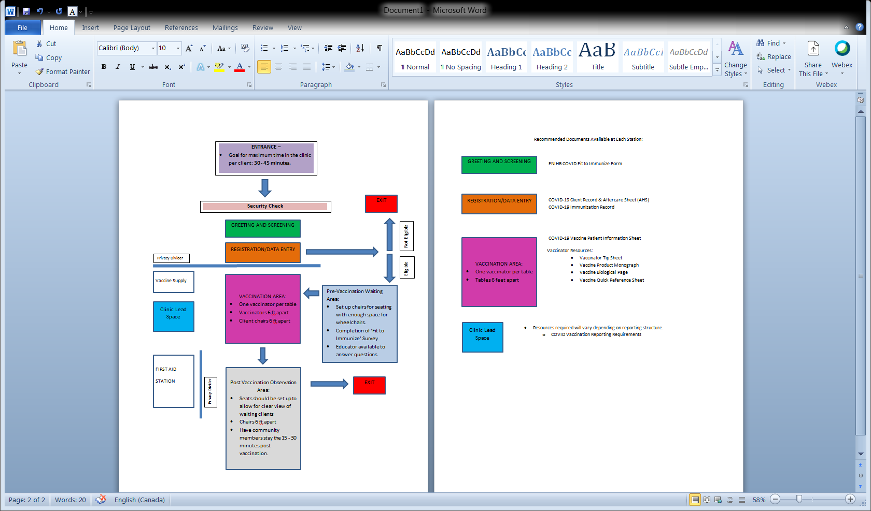

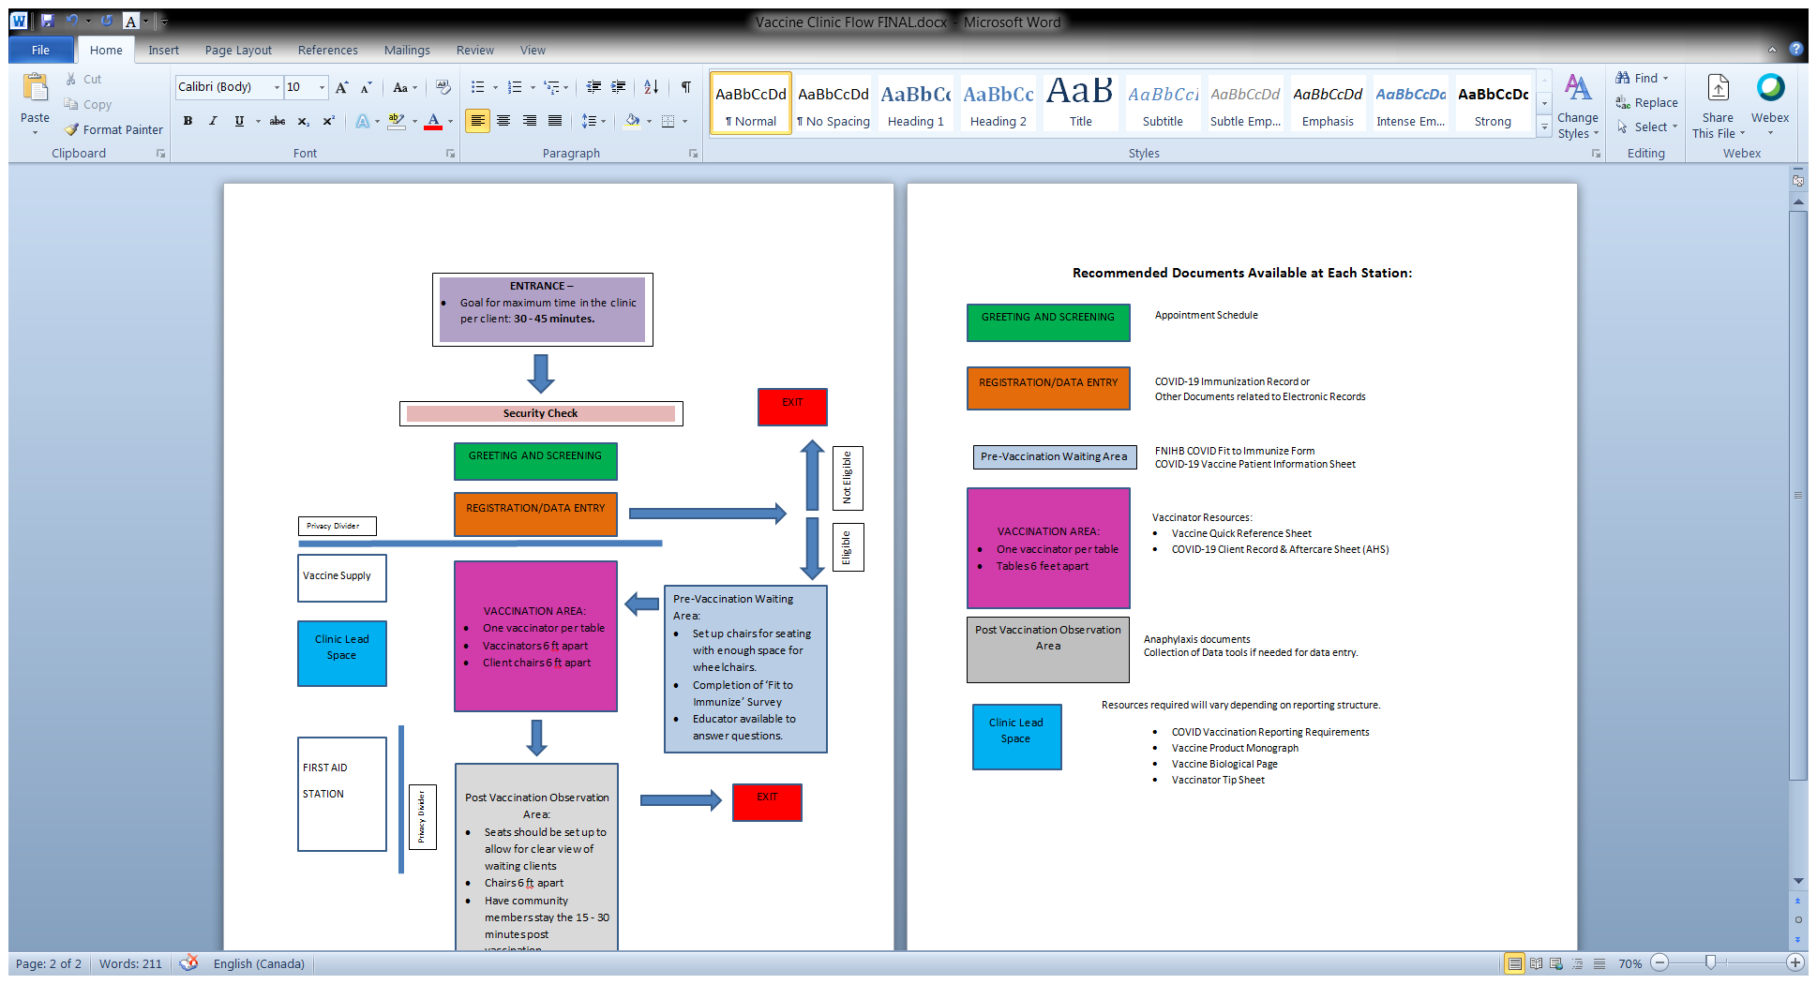

COVID-19 Client Record & Aftercare Sheet (AHS)

COVID-19 Immunization Record

FNIHB COVID Fit to Immunize Form

COVID-19 Vaccine Patient Information Sheet

Vaccinator Resources:

* Vaccinator Tip Sheet
* Vaccine Monograph
* Vaccine Biological Page
* Vaccine Quick Reference Sheet

Vaccinator Resources:

* Vaccinator Tip Sheet
* Vaccine Product Monograph
* Vaccine Biological Page
* Vaccine Quick Reference Sheet









Triage of Persons Presenting for mRNA Vaccine

|  |  |  |  |
| --- | --- | --- | --- |
|  | **MAY PROCEED WITH VACCINATION** | **PRECAUTION TO VACCINATION** | **CONTRAINDICATION TO VACCINATION** |
| **CONDITIONS** | **CONDITIONS:**   * Immunocompromising conditions * Pregnancy * Lactation   **ACTIONS:**   * Additional information provided * 15 minute observation period | **CONDITIONS:**   * Moderate/severe acute illness   **ACTIONS:**   * Risk assessment * Potential deferral of vaccination * 15 minute observation period if vaccinated | **CONDITIONS:**   * Under 18 years of age.   **ACTIONS:**   * Do not vaccinate |
| **ALLERGIES** | **ALLERGIES:**   * History of food, pet, insect, venom, environmental, latex, or other allergies not related to vaccines or injectable therapies. * History of allergy to oral medications (including the oral equivalent of an injectable medication) * Non-serious allergy to vaccines or other injectables (eg. No anaphylaxis) * Family history of anaphylaxis * Any other history of anaphylaxis that is not related to a vaccine or injectable therapy   **ACTIONS**:   * 30 minute observation period. Persons with a history of severe allergic reactions (eg. Anaphylaxis) due to any cause * 15 minute observation period. Persons with allergic reaction but not anaphylaxis. | **ALLERGIES:**   * History of severe allergic reactions (eg anaphylaxis) to another vaccine (not including Pfizer or Moderna vaccine – dependent on the vaccine available for the clinic) * History of severe allergic reaction (eg. Anaphylaxis) to an injectable therapy   **ACTIONS:**   * Risk assessment * Potential deferral of vaccination * 30 minute observation period if vaccinated | **ALLERGIES:**   * History of severe allergic reaction (eg anaphylaxis) to any component of the Pfizer or Moderna vaccine (depending on the vaccine being delivered in the clinic)   **ACTIONS:**   * Do not vaccinate |

Adapted from: Interim Clinical Considerations from Use of mRNA COID-19 Vaccines Currently Authorized in the US