Mental Health and Extreme Weather – Mental Health Communications Toolkit
Table of Contents

About this Toolkit…………………………………………………………………………………3

Part 1: Resources…………….………………………………………………………................4

Part 2: Key Messages……………………………………………………………………………5

Part 3: Social Media Shareables……………………………………………………………..…6

About this Toolkit

The Government of Canada recognizes that the wildfire situations, and other weather events across the country continue to create stress and anxiety for many, particularly those who do not have ready access to their regular support networks.
Mental health is an integral component of health, it is important that people within Canada have access to mental health supports during these difficult times.
This toolkit aims to raise awareness of much needed Government of Canada resources and tools to support the mental health and well-being of Canadians.
In this toolkit, you will find:
- Resources for support: Available resources and services for diverse audiences, including information about Wellness Together Canada and PocketWell.
- Key messages: Suggested messaging to use to raise awareness about mental health resources available.
- Social media shareables: Content and infobytes ready to publish and share on your social media channels.

Resources for Support

Wellness Together Canada (WTC) provides free and confidential mental health and substance use support; you can also use its PocketWell app to help assess and monitor your mood and well-being.  WTC is available to anyone in Canada or Canadians abroad who are looking for mental health or substance use help. | - Wellness Together Canada  - PocketWell is available as a free download from the App Store or the Google Play Store.
Hope For Wellness provides immediate emotional support, crisis intervention, or referrals to community-based services can access experienced and culturally sensitive help line counsellors for Indigenous Peoples. | - Hope For Wellness  - Help Line at 1-855-242-3310
Youth | - Kids Help Phone  - Jack.org
Suicide and self-harm | - Talk Suicide Canada  - For residents of Quebec: 1-866 APPELLE (1-866-277-3553) or suicide.ca
Get help with substance use  This page has resources and information for people who need help with substance use, including overdose prevention resources. | - Get help with substance use
Chronic pain  About chronic pain, different options that may be available to help people manage their pain, and the Government of Canada’s role in supporting people living with pain.  Power Over Pain Portal  A virtual platform that provides Canadians rapid access to free evidenced-based virtual resources, interventions and peer support to help youth and adults manage their chronic pain. | - https://www.canada.ca/en/public-health/services/diseases/chronic-pain.html  - https://poweroverpain.ca/
Key Messages

- Supporting the mental health and well-being of everyone in Canada is a priority for the Government of Canada. In 2020, the Government launched Wellness Together Canada (WTC), an online portal that provides access to a virtual network of psychosocial supports.
- Through WTC, individuals across the country can access free, 24/7 mental health and substance use supports and services ranging from self-assessment and peer support, to confidential sessions with social workers, psychologists and other professionals.
- WTC offers services in both official languages. Phone-counselling sessions are also available in over 200 languages and dialects, through instantaneous interpretation.
- During difficult times, including extreme weather events or emergencies it is critical that everyone in Canada have access to much needed resources and tools to support their mental health and well-being, and obtain credible and reliable information that they can share with friends, families and community members.

- The Government of Canada recognizes that this year’s wildfire situation continues to create stress and anxiety for many, particularly those who do not have ready access to their regular support networks. WTC complements existing provincial and territorial services. We encourage everyone in Canada to make their mental health a priority and reach out to the services available in their area.

- To connect with a mental health professional one-on-one:
  - call 1-888-668-6810 or text WELLNESS to 686868 for youth
  - call 1-866-585-0445 or text WELLNESS to 741741 for adults
  - You can also visit Wellness Together Canada to access different levels of support, including:
    - one-on-one counselling
    - credible articles and information
    - self-guided courses and programs
    - peer support and coaching

- The Hope for Wellness Help Line offers immediate help to all Indigenous peoples across Canada. It is available 24 hours a day, 7 days a week to offer immediate support and crisis intervention. Call the toll-free Help Line at 1-855-242-3310 or connect to the online chat at www.hopeforwellness.ca.

Social Media Shareables

Social media shareables are one way to reach out to your network and share credible mental health and well-being information and resources.

Platform | Message
Twitter | It is normal to feel anxious or isolated during a wildfire event or evacuation. If you experience any feelings of stress, anxiety, depression or distress, contact your mental health care provider for advice or visit: https://www.wellnesstogether.ca/en-CA | 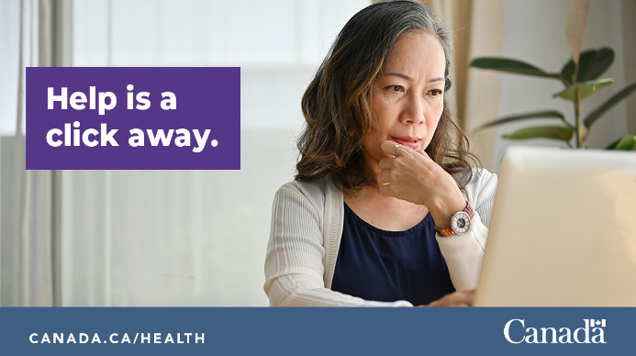
Twitter | Take care of your mental health during a wildfire event or evacuation. Having trouble coping with symptoms of stress, anxiety, depression or distress? Seek help from a mental health professional or visit: https://www.wellnesstogether.ca/en-CA | 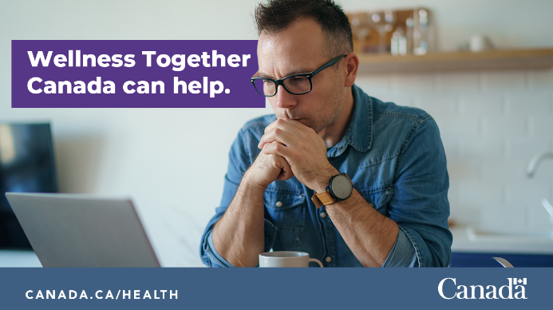
Twitter  *Note: The Hope for Wellness Help Line offers immediate help to all Indigenous peoples across Canada | Have you been affected by forest fires or flooding? If you are feeling distressed and need crisis intervention counselling, call the Hope for Wellness Help Line to talk to experienced Help Line counsellors at 1-855-242-3310 or chat online at hopeforwellness.ca. | 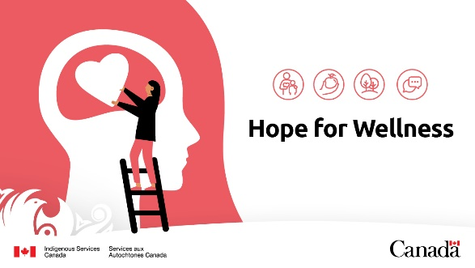
Facebook | It is normal to feel anxious or isolated during a wildfire and wildfire smoke event or evacuation.  If you experience any feelings of stress, anxiety, depression or distress, contact your mental health care provider for advice or visit: https://www.wellnesstogether.ca/en-CA
Facebook | Take care of your mental health during a wildfire and wildfire smoke event. Having trouble coping with symptoms of stress, anxiety, depression or distress? Seek help from a mental health professional or visit: https://www.wellnesstogether.ca/en-CA | 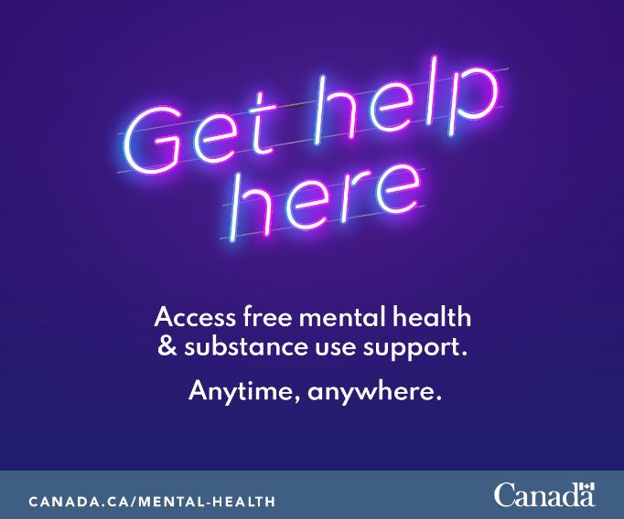
Facebook  *Note: The Hope for Wellness Help Line offers immediate help to all Indigenous peoples across Canada | Have you been affected by forest fires or the wildfire smoke? If you are feeling distressed and need crisis intervention counselling, call the Hope for Wellness Help Line to talk to experienced Help Line counsellors at 1-855-242-3310 or chat online at hopeforwellness.ca. | 