**Text for accessibility**

**Description**

The text below is the same text found on the iGAS images for social media and postering. They have been labelled according to their titles. Small versions have been included for each, for your ease of reference. For some readers, the text may be more informative than the graphics, such as people who are blind and/or have a reading disability.

If you haven’t used ALT text before, the text below can be shared directly with people who need it, or uploaded alongside the images. Most social media sites have the option to add descriptions to each photo during the uploading process, also known as ALT text. ALT text stays hidden from viewers unless it is clicked on, or a screen reading device reads it out loud. It does not count towards the total characters on platforms that limit characters, like X (formerly Twitter).

On most social media sites, you will only have the option to add ALT text once you have attached an image. It may be labelled “add description”, “edit”, or just “ALT”.

**Images**

**Image title: Protecting against iGAS**

What is iGAS?

iGAS is a contagious bacterial infection. It can lead to serious and life-threatening health issues, like brain swelling and flesh-eating disease.

Who is at risk?

Anyone can get an iGAS infection, but some are at higher risk. This includes Elders; pregnant people; those with chronic diseases (like diabetes and heart disease); and those with weakened immune systems. Substance abuse and breaks in the skin (such as cuts or eczema) are also risk factors.

How can I protect myself and others?

* Stay home when you’re sick and seek treatment ASAP if you don’t improve
* Always finish your antibiotics
* Wash your hands often
* Stay up-to-date on vaccines
* Don’t share personal items
* Cover coughs and sneezes
* Wear a mask indoors

If you have symptoms, stay home, limit your contact with others, and contact the nursing station

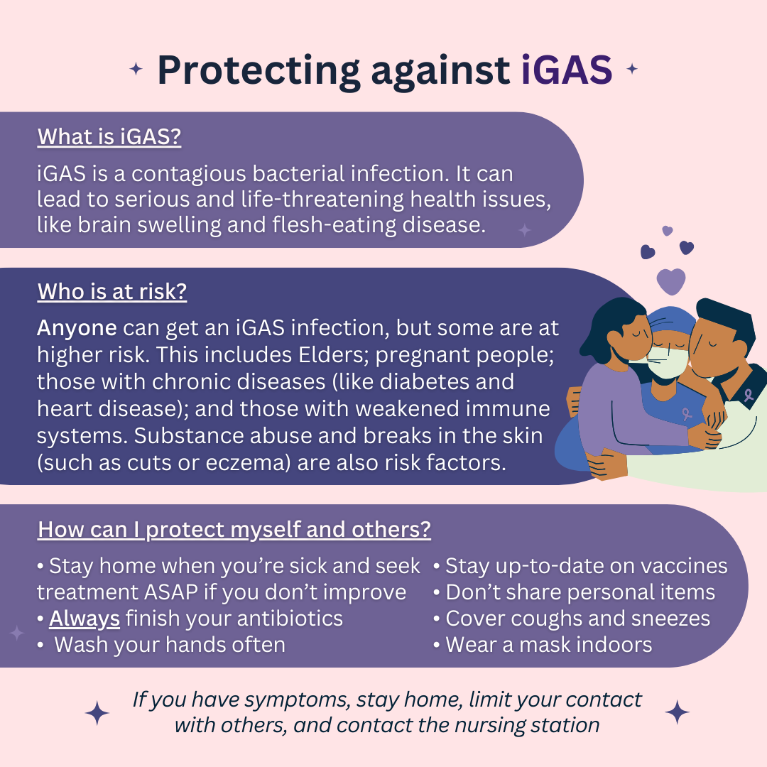

**Image title: Are you iGAS aware?**

Are you up to date?

Group A Streptococcus (GAS) is a common bacteria, spread through respiratory droplets and open wounds.

iGAS happens when GAS becomes invasive. iGAS is a serious infection, often developing in

a matter of hours.

You’re at a higher risk of getting iGAS if you recently had a viral infection, like COVID-19, the flu, or RSV.

There is no vaccine for iGAS.

The best protection is prevention.

Make sure you’re caught up on your immunizations to help keep your immune system strong.

Contact the local health centre, nursing station, or public health unit for more information.

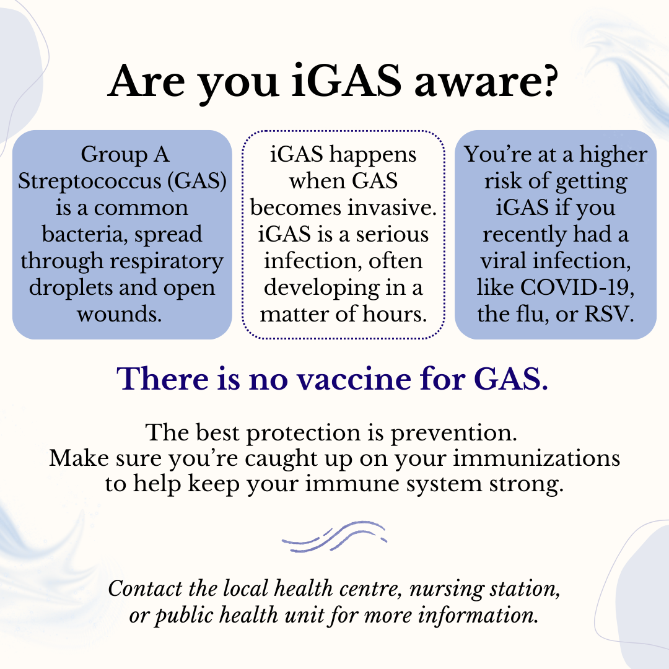

**Image title: Group A Streptococcus**

GAS is an infection caused by Group A Streptococcus (GAS) bacteria. GAS mainly spreads by breathing in respiratory droplets or touching open wounds. This can happen through coughing, sneezing, kissing, touching open sores, or sharing personal items like toothbrushes.

SYMPTOMS

Flu-like

* Fever
* Tired
* Chills
* Muscle aches

Stomach

* Upset stomach
* Diarrhea
* Vomiting

Skin

* Wound infection
* Skin infection
* Rash (may be rough)

Throat

* Extremely sore
* Doesn’t improve

Cognitive

* Change in alertness
* Confusion
* Dizzy

Respiratory

* Trouble breathing
* Possible pneumonia

TREATMENT

Early treatment is very important. GAS is treated with antibiotics. Starting your antibiotics ASAP lowers your risk of having serious health complications and lowers your chance of spreading GAS.

For more information about GAS, please contact your community health centre or public health unit.

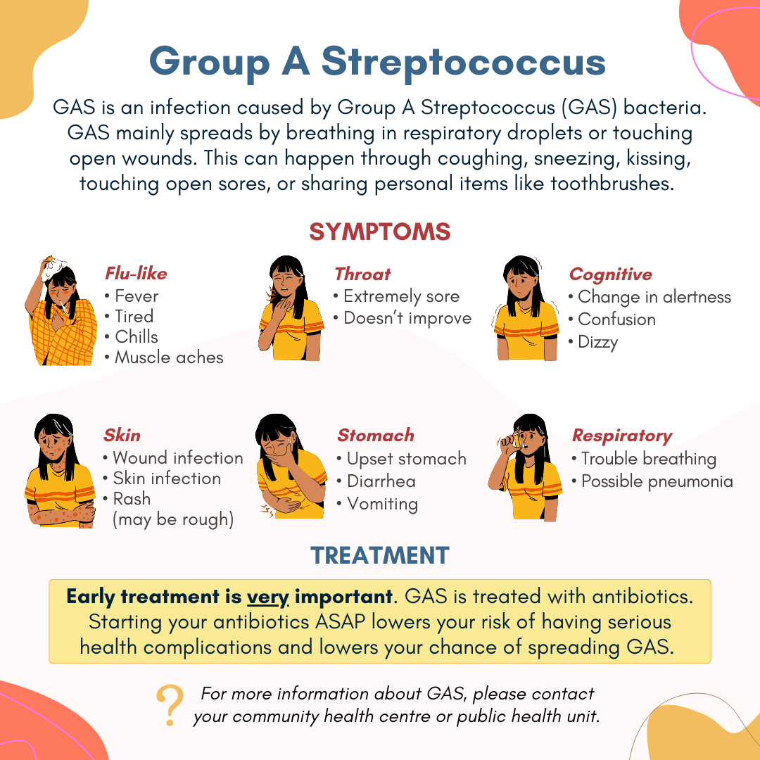

**Image title: What is iGAS? Invasive Group A Streptococcus (iGAS)**

Group A Streptococcus (GAS) is a bacterium that usually causes mild infections, like strep throat. GAS spreads by breathing in respiratory droplets, touching open wounds, or close contact with an infected person’s nose or mouth.

Invasive GAS or “iGAS” happens when GAS causes a more serious bacterial infection, like meningitis or toxic shock syndrome.

iGAS symptoms can include (or worsen to include):

* Flu-like symptoms (fever, tired, chills, muscle aches)
* Upset stomach, vomiting or diarrhea
* Infected skin/wound (pain, swelling)
* Dizziness or change in alertness
* Trouble breathing
* Rash (may be rough to the touch)

Protect yourself by following the same steps you would during respiratory illness season, such as wearing a mask and:

* Stay home if you’re sick
* Always finish antibiotics
* Wash your hands often
* Stay up-to-date on vaccines
* Don’t share personal items
* Cover coughs and sneezes

Call the nursing station if you have symptoms of GAS and seek medical care immediately if you have symptoms of iGAS.

