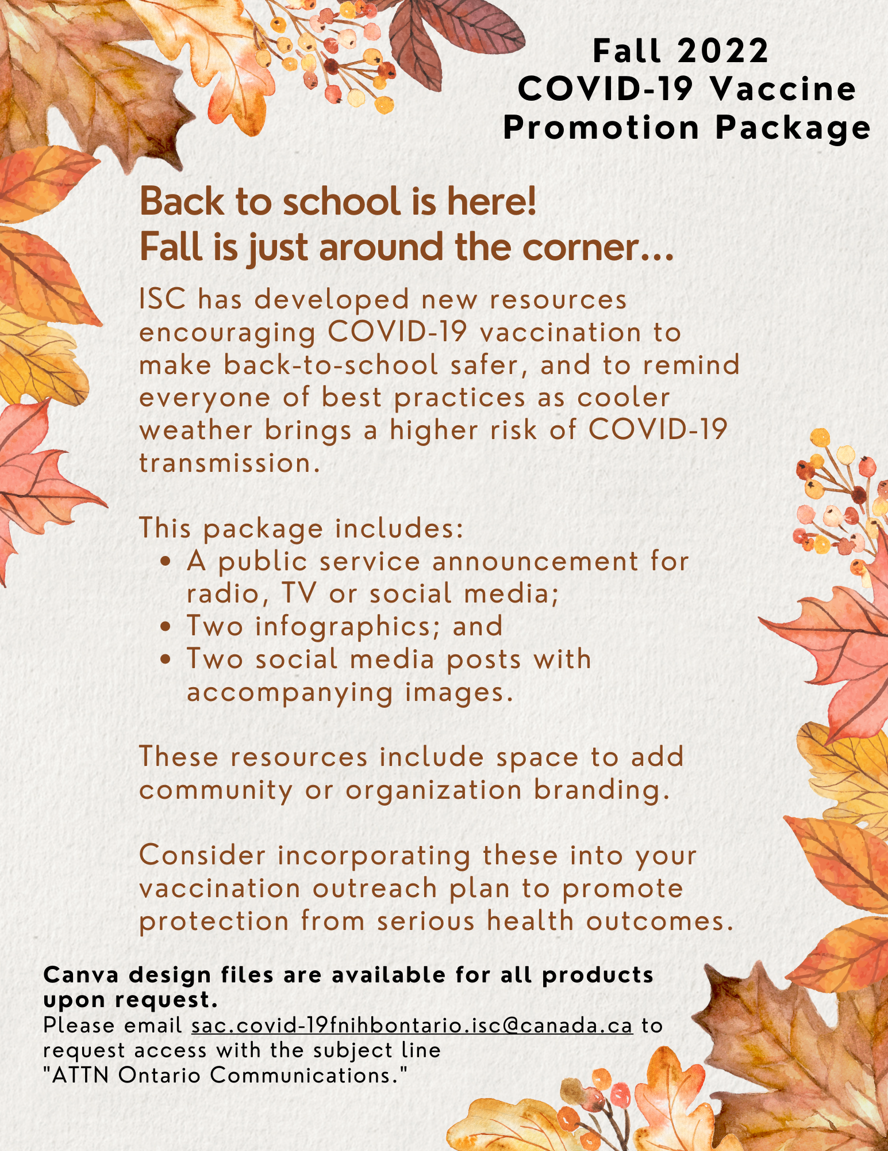

Public service announcement (radio script / talking points): The importance of vaccination as fall approaches
"Hello, I am … and I am here to talk to you about the importance of being vaccinated as fall approaches.
The leaves will soon turn to oranges and yellow, and the days are getting shorter. Children are back in school learning and growing.
We have learned that being indoors with people who we don’t live with increases our risk of getting COVID-19. As we start gathering indoors more often in the comfort of family, friends, and home, we must remember that COVID-19 is still with us. This fall, let’s use the wisdom we have gained about COVID-19 to protect ourselves and each other.
To protect yourself, your children, and to keep your elders safe, now is the time to get COVID-19 vaccines. It’s important to stay up-to-date on the vaccine, which for most people, means getting at least three doses. But, for those who are older or have other medical conditions, being up-to-date may mean four or more doses. The vaccines must be spaced out at intervals ranging from two to six months depending on factors including your age, current vaccination status and recent COVID-19 infection.
If you are unsure about eligibility or time frames for next doses, call your local nursing station or speak to your health care provider. They will be able to answer any questions you have.
It’s also a good idea to get the flu shot this fall. We’ve all been pretty protected from other illnesses, like the flu, because of mask-wearing and limiting our interactions with each other. As restrictions continue to ease, your risk of getting the flu may be higher this fall and winter.
Protecting yourself and others from the spread of COVID-19 also includes wearing face masks. While this is no longer mandated provincially or federally, the decision to require masks to enter private businesses and certain buildings in different communities is up to the discretion of business owners and community leadership.
Some people may decide that they will continue wearing masks based on their personal circumstances and comfort level, and that decision should be met with respect. Kindness and compassion go a long way, especially as we all navigate the stress and fatigue associated with a long two years living through a global pandemic.
Together, we can keep our community strong and healthy and enjoy a safe fall. Thank you.”

Infographic 1: Back to school checklist
This can be posted on social media or printed out and displayed around your community.

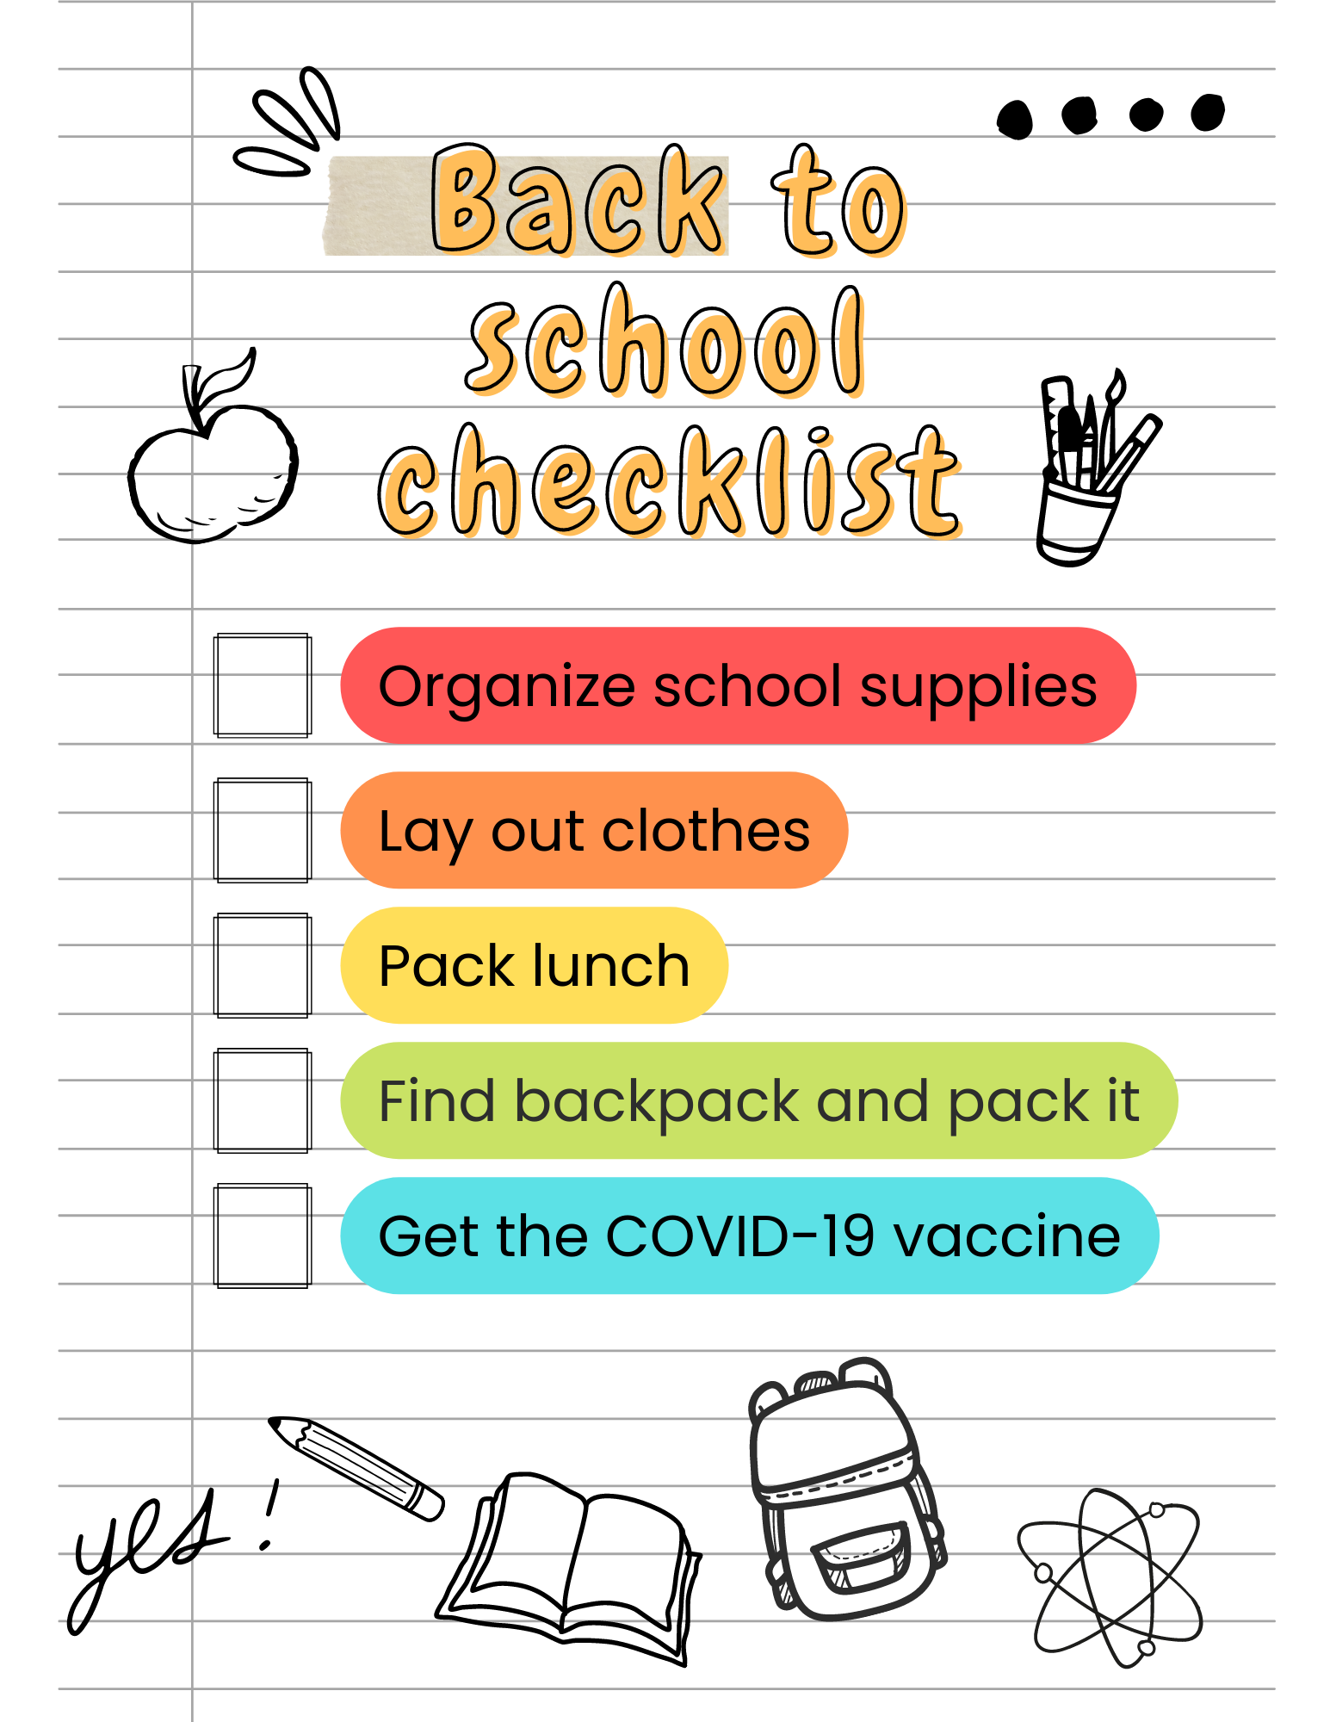
Image downloadable here – with space for branding:
https://www.onehealth.ca/LinkClick.aspx?fileticket=8DaoA0FRytw%3d&portalid=4

Image downloadable here – without space for branding:
https://www.onehealth.ca/LinkClick.aspx?fileticket=sWcllZZ0hn0%3d&portalid=4
Infographic 2: Back to school checklist
This can be posted on social media or printed out and displayed around your community.
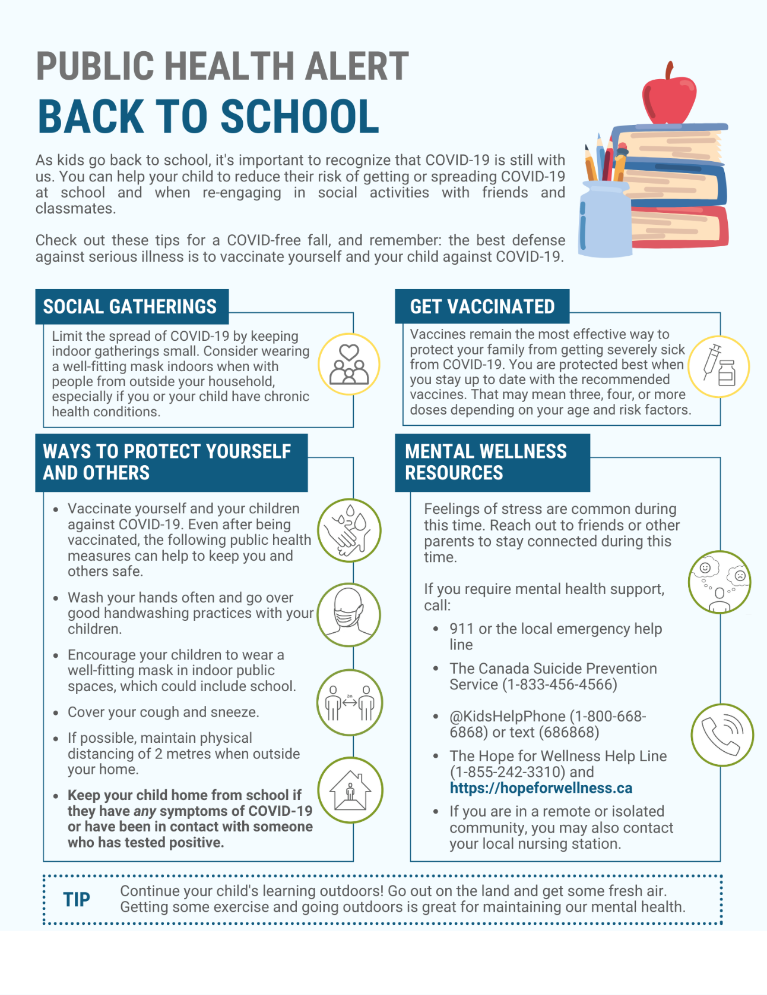
Image downloadable here:
https://www.onehealth.ca/LinkClick.aspx?fileticket=LiIageNXsgI%3d&portalid=4

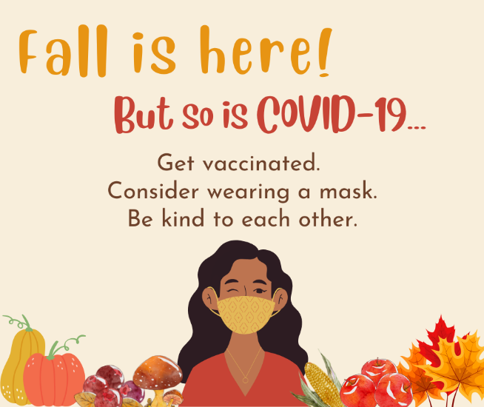
Social media post 1

Image downloadable here – with space for branding:
https://www.onehealth.ca/LinkClick.aspx?fileticket=oNTRYP4fj0Y%3d&portalid=4

Image downloadable here – without space for branding:
https://www.onehealth.ca/LinkClick.aspx?fileticket=05zzAbgHJmQ%3d&portalid=4

Suggested social media post text to accompany the image:
Fall is here! But so is COVID-19. You can help to protect yourself, your family, and others in your community as kids head back to school and gatherings shift indoors.
Vaccinate yourself and your kids against COVID-19 and stay up-to-date by getting all doses for which you are eligible.
Consider wearing a mask at indoor public events, especially if you have chronic health conditions.
And don’t forget to be kind to others, including those who may make different choices than you.
Find out which doses of the COVID-19 vaccine you are eligible for here: https://covid-19.ontario.ca/covid-19-vaccines-first-nations-inuit-and-metis-people

Social media post 2
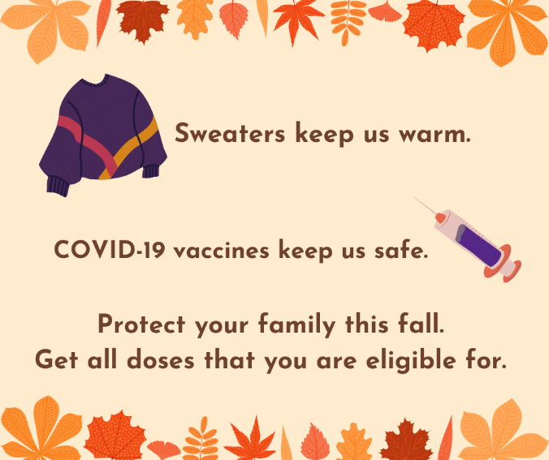

Image downloadable here – with space for branding:
https://www.onehealth.ca/LinkClick.aspx?fileticket=eSWXEgJEcq0%3d&portalid=4

Image downloadable here – without space for branding:
https://www.onehealth.ca/LinkClick.aspx?fileticket=hE7sSi8uvpc%3d&portalid=4
Suggested social media post text to accompany the image:
Just like a sweater keeps us warm in fall, the COVID-19 vaccine helps to protect us against serious illness and death.
With kids back in school and colder weather forcing us inside more often, be sure to vaccinate your family against COVID-19.
Staying up-to-date on the vaccine and getting all the doses for which you are eligible is one of the best ways to protect your family this fall. For most people, this means getting at least three doses of the vaccine.
Find out more about the COVID-19 vaccine and the doses you can get here: https://covid-19.ontario.ca/covid-19-vaccines-first-nations-inuit-and-metis-people

