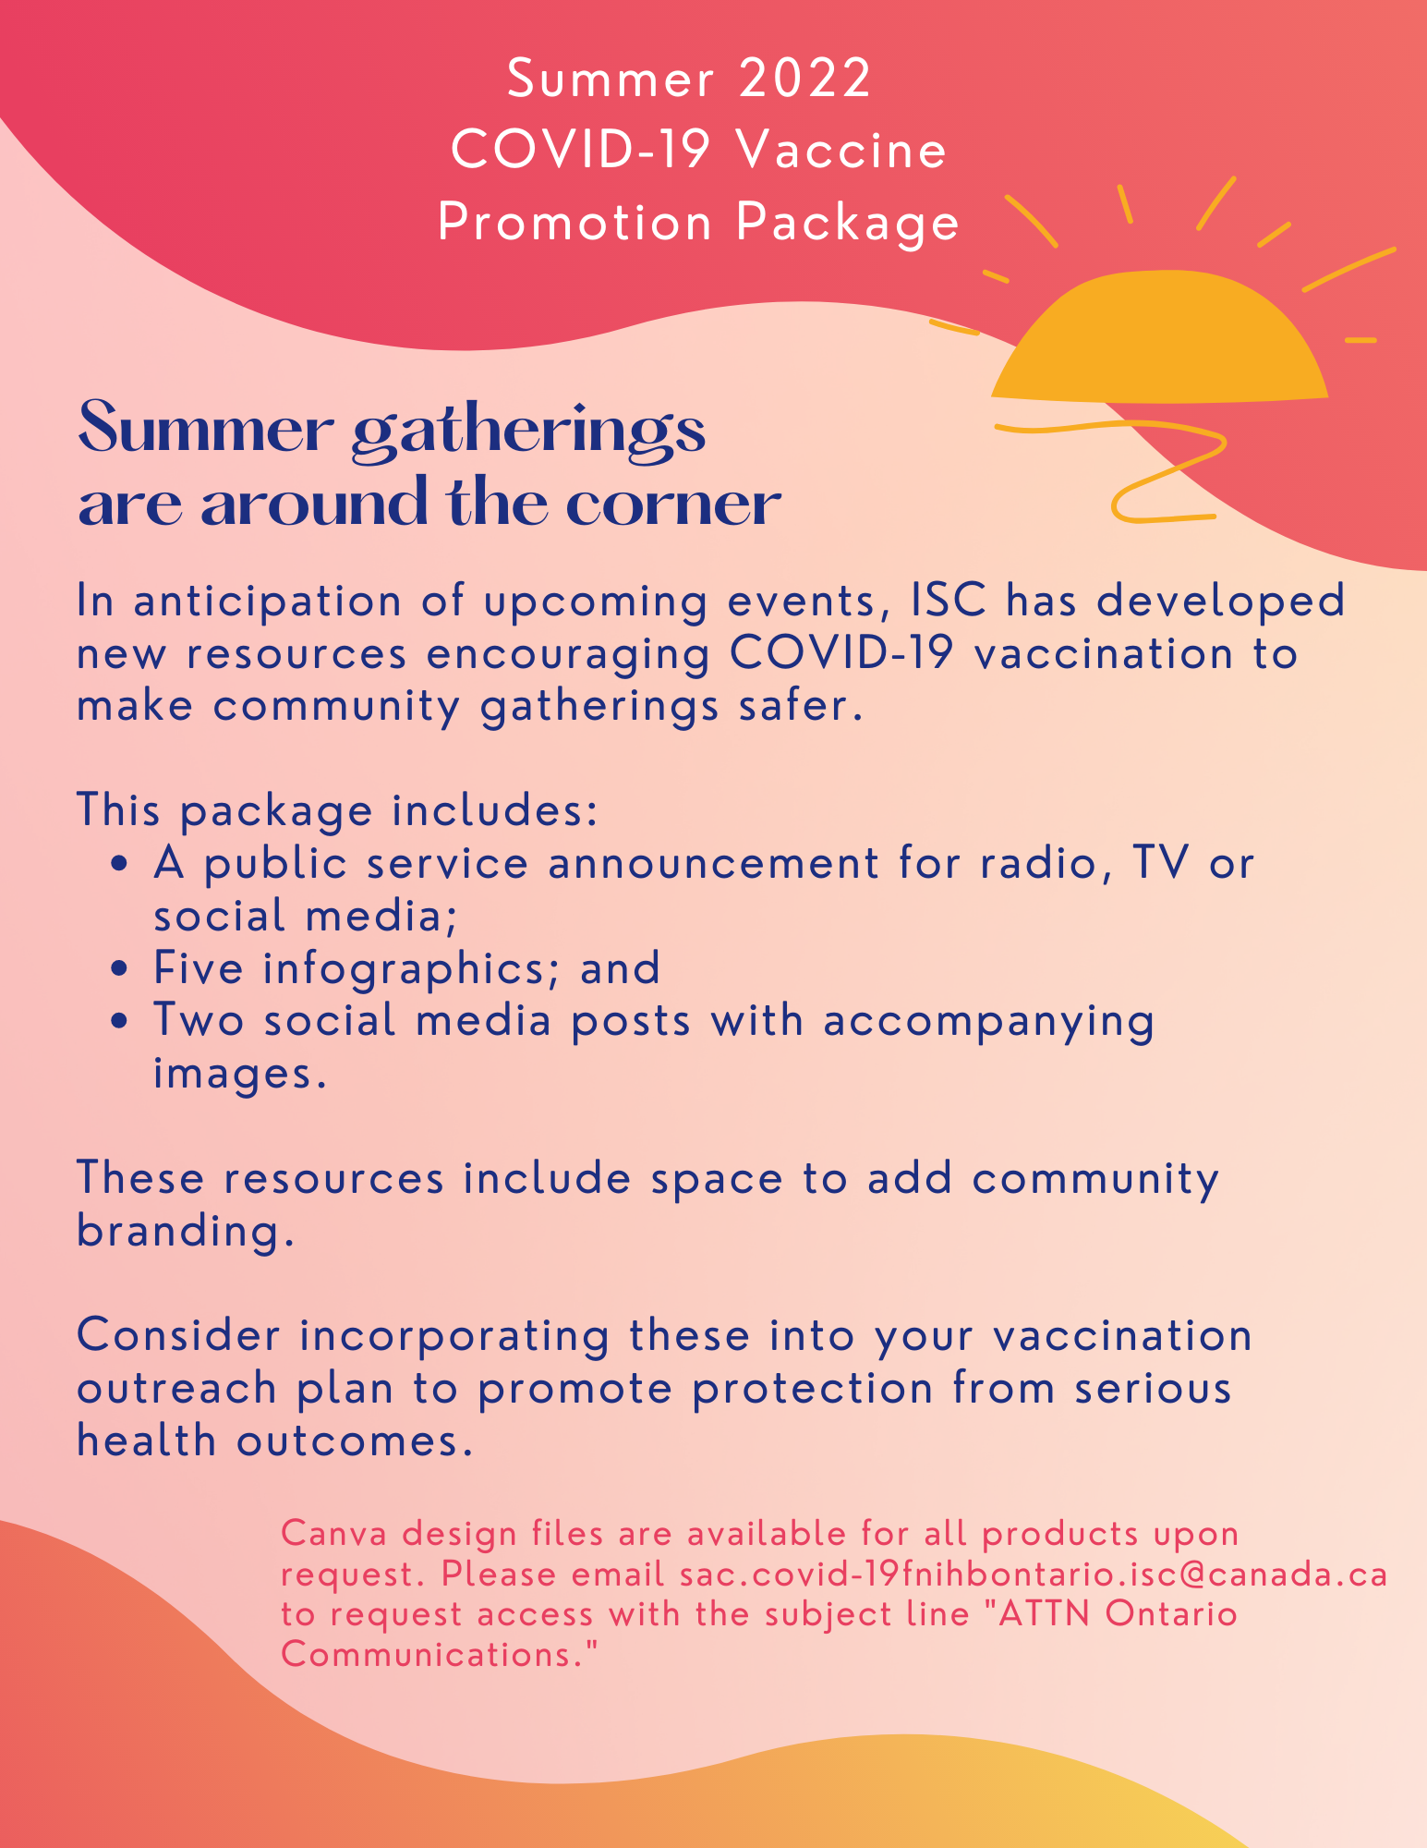
All items are available for download at https://www.onehealth.ca/on/home/ontario
Infographic 1:
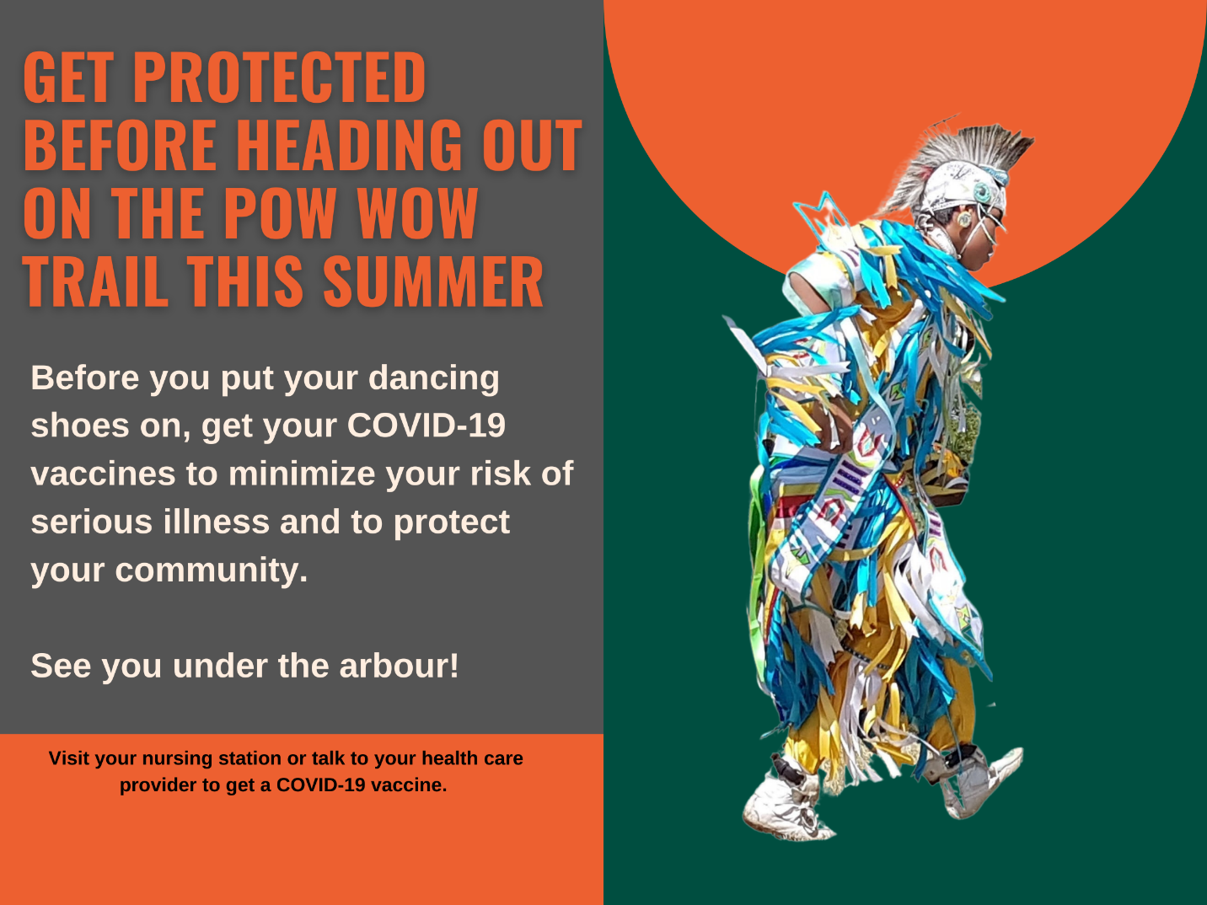
Downloadable here: https://www.onehealth.ca/LinkClick.aspx?fileticket=n0jVUC2QWzk%3d&tabid=1263&portalid=4

Infographic 2:
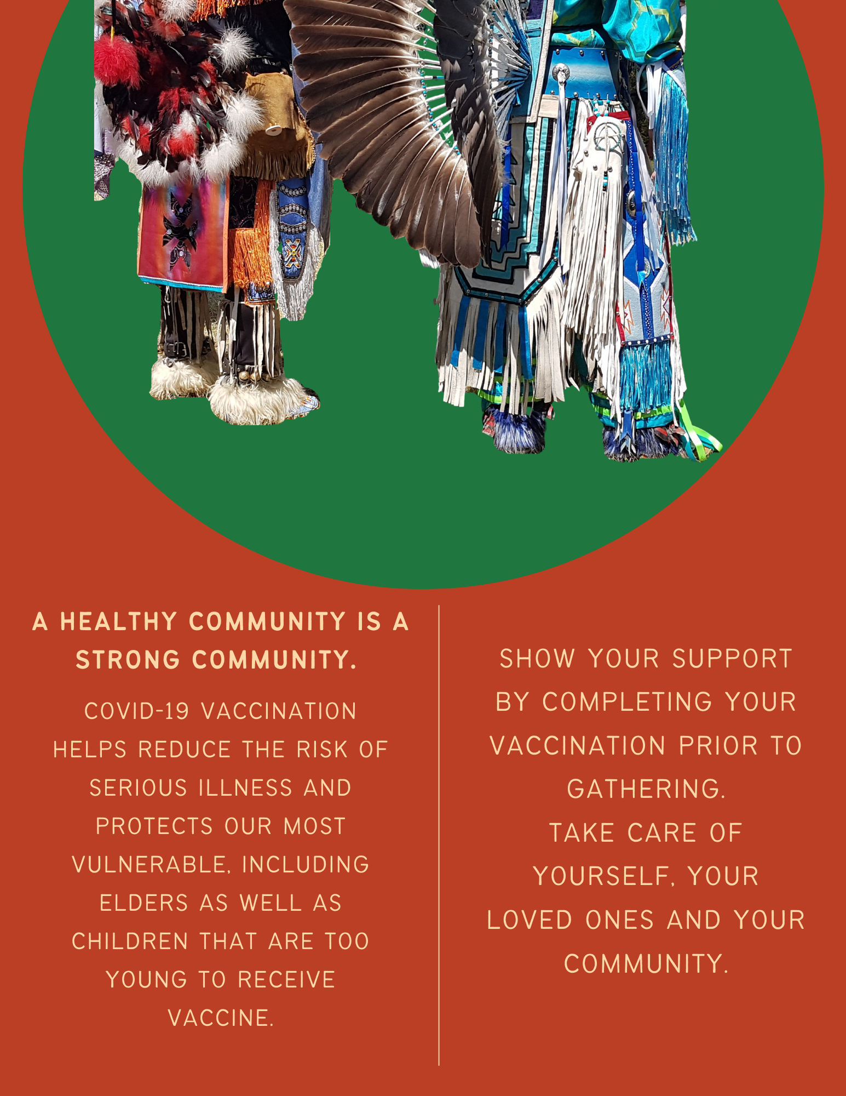
Downloadable here: https://www.onehealth.ca/LinkClick.aspx?fileticket=ysh9aGAFHmM%3d&tabid=1263&portalid=4

Infographic 3:
Downloadable here: https://www.onehealth.ca/LinkClick.aspx?fileticket=nEGwe81QMe0%3d&tabid=1263&portalid=4
Infographic 4:
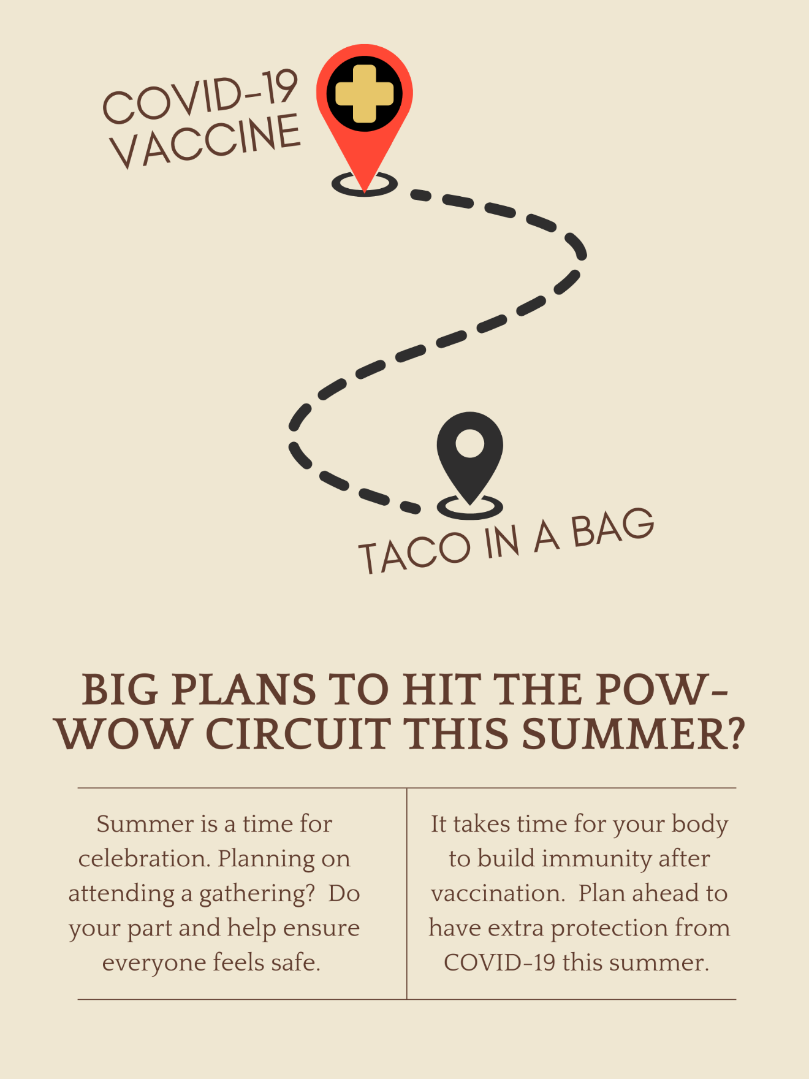
Downloadable here: https://www.onehealth.ca/LinkClick.aspx?fileticket=pZaH75emHOE%3d&tabid=1263&portalid=4
Infographic 5:
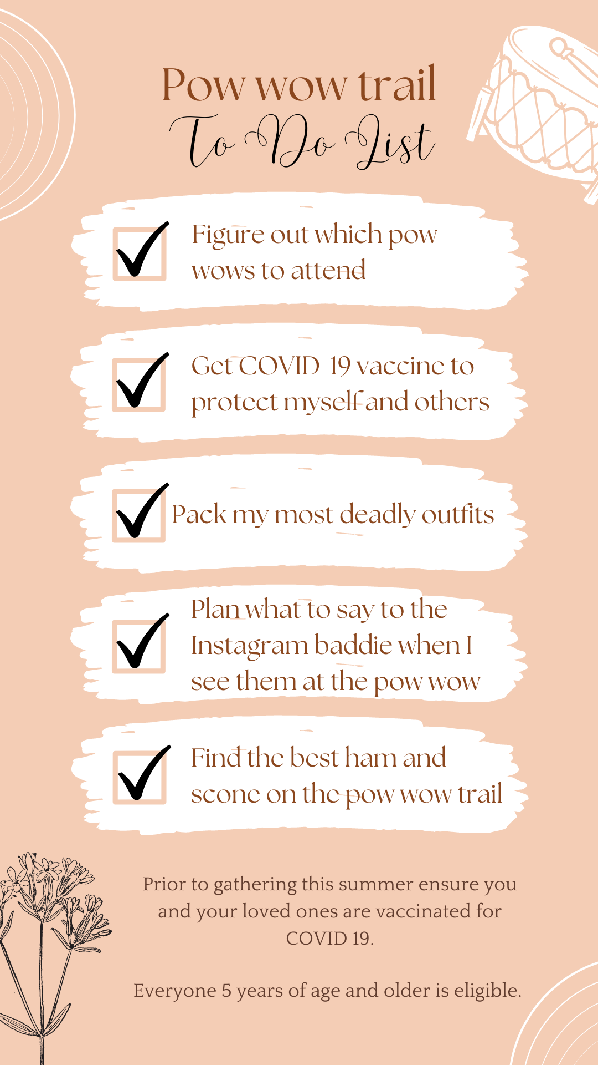
Downloadable here: https://www.onehealth.ca/LinkClick.aspx?fileticket=yvqEMmMDm2U%3d&tabid=1263&portalid=4
Public service announcement (radio script / talking points): The importance of vaccination before summer gatherings
"Hello, I am … and I am here to talk to you about the importance of being vaccinated before attending mass gatherings this summer.
The days are longer. The world is much more colourful with flowers blooming, green grass peeking up from the earth, and leaves budding on every tree branch.
As we venture outside to embrace the warmer weather and begin to plan our summer itineraries, we must be mindful that COVID-19 is still with us. There are many celebrations to look forward to in the coming months, and with some thoughtful planning we can all enjoy them as safely as possible.
To protect yourself and to keep your elders safe at pow wows; community gatherings; and other celebrations; now is the time to prioritize COVID-19 vaccines. The vaccines must be spaced out at intervals ranging from two to six months depending on factors including your age, current vaccination status and recent COVID-19 infection.
If you are unsure about eligibility or time frames for next doses, call your local nursing station or speak to your health care provider. They will be able to answer any questions you have.
Protecting yourself and others from the spread of COVID-19 also includes wearing face masks. While this is no longer mandated provincially or federally, the decision to require masks to enter private businesses and certain buildings in different communities is up to the discretion of business owners and community leadership. Some people may decide that they will continue wearing masks based on their personal circumstances and comfort level, and that decision should be met with respect. Kindness and compassion go a long way, especially as we all navigate the stress and fatigue associated with a long two years living through a global pandemic.
Together, we can keep our community strong and healthy and enjoy a safe and fun-filled summer. Thank you.”

Social Media Post 1:
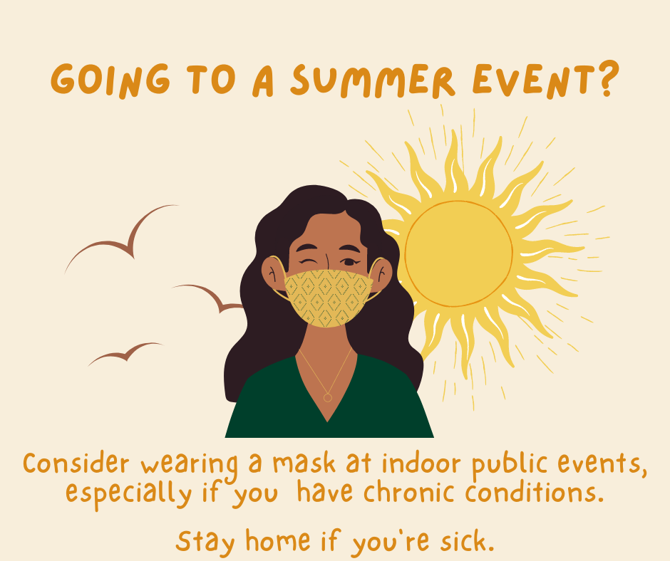
Image downloadable here: https://www.onehealth.ca/LinkClick.aspx?fileticket=HdIwQgKfIWU%3d&tabid=1263&portalid=4
Suggested social media post text to accompany the image:
Summer is almost here! If you’re planning on attending a pow wow or another summer event, protect yourself and those around you from COVID-19. Wear a mask at public events, even if outside, to avoid getting or spreading COVID-19. Show respect for your community by staying at home if you are ill, even if your symptoms are mild.

Social Media Post 2:
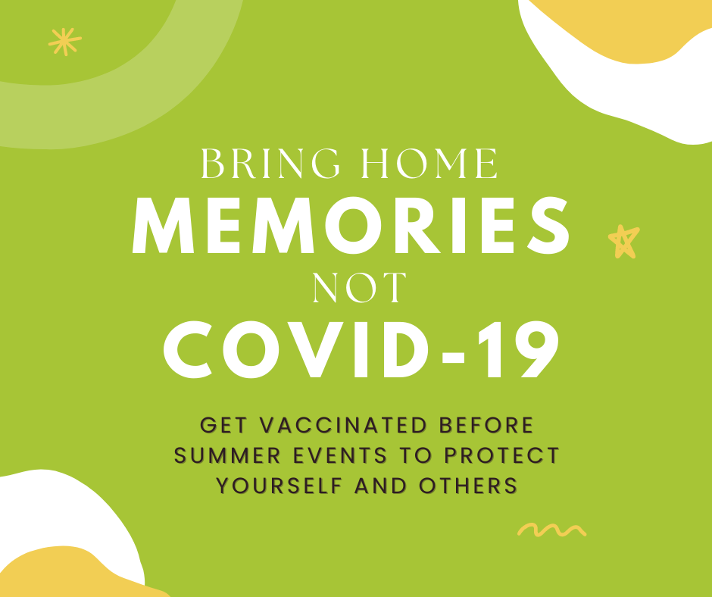
Image downloadable here: https://www.onehealth.ca/LinkClick.aspx?fileticket=rc9WDcZz3uk%3d&tabid=1263&portalid=4
Suggested social media post text to accompany the image:
Are you ready for pow wow season? Don’t bring home an unwanted souvenir! Get vaccinated now to boost your protection against COVID-19 for upcoming summer events. Complete all doses that you are eligible for to increase your level of protection.

