Vaccinator Tip Sheet

Prior to going to community:
- Is CHIP program accessible during the clinic (registration/documentation)?
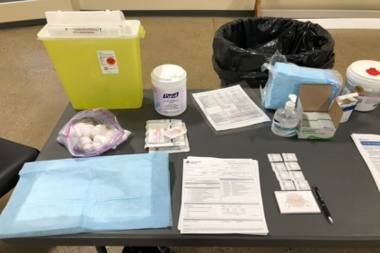
- Do you have your complete Immunization Certification? If no, have you completed the required training (EPIC modules, etc.).

Set Up at Vaccinating Station
- Sharps container
- Hand sanitizer
- Cavi wipes (or equivalent)
- Blue pads (fold over a blue pad and keep your multi-dose vial underneath)
- Pen (for vaccinator use only)
- Syringes (1mL or 3 mL)
- Needles (25g and 5/8 length)
Keep the sharps container and supplies far enough away from the edge of the table to avoid contamination (and space to sanitize with Cavi-Wipes after each immunization).
- Alcohol wipes
- Bandaids (if needed)

PPE Required:
- Medical masks (not cloth)
- Face shield/medical goggles
- Disposible long sleeve gown
- Gloves available (not required for vaccinating if proper hand hygiene performed).

Process:
Patient Education and Screening:
- Greet patient, introduce self, and verify correct patient using at least two identifiers (name, DOB)
- Explain what vaccine will be given (Pfizer or Moderna COVID-19 vaccine) and which type of injection will be done (IM)
- Verify patient has discussed the FNIHB ‘COVID Fit to Immunize’ form and that all of their questions and concerns have been addressed
- Verify screening for contraindications and precautions to vaccination (refer to algorithm below)
- Educate patient on what to expect after vaccination (possible side effects, interventions, when to report side effects)
- Educate on need to come back for 2nd dose of vaccine (same product as 1st dose, days as per vaccine availability). Have dates available based on date of the clinic.
Vaccine Preparation:
- Perform hand hygiene
- Inject amount of air into the vial consistent with vaccine volume to be given
- Draw up the vaccine using a 25g needle and verify the final dosing volume (dependent on vaccine given)
- Confirm there are no particulates or discolouration observed
Vaccine Administration:
- Gather appropriate supplies for administration (drawn up vaccine, band aid, cotton ball, alcohol pad)
- Position patient and self ergonomically (have patient relax their arm and place on their lap)
- Have patient expose their entire preferred arm by rolling sleeve up to shoulder
- Locate acromion process (bony tip of shoulder)
- Measure 2-3 fingerbreadths directly below the acromion process.
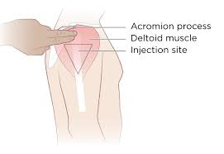
- Clean site with an alcohol wipe using circular motion from center to a 2”-3” circle. Allow to dry
- Stabilize patient’s arm with the non-dominant hand (do not bunch), hold the needle an inch from the skin, and insert it quickly at a 90 degree angle
- Inject vaccine using steady pressure, making sure full dose is administered, before withdrawing the needle quickly at the same angle
- Immediately activate safety device and dispose syringe in a sharps container
- Have patient apply gentle pressure to the injection site for several seconds with a dry cotton ball, if needed
- Apply band aid to injection site if required
- Perform hand hygiene
Documentation:
- Document immunization details on patient’s record (or in CHIP if available), provide a copy of immunization and 2nd dose reminder.

Resources for immunizers (nurses) that must be available at the immunization clinic:
- Medical Directives:
  - Continuous Mask and Eye Protection
  - COVID vaccination
  - Anaphylaxis
- Vaccine Product Monograph
- Vaccine Biological Page
- Vaccine Quick Reference Guide

Donning and Doffing of Personal Protective Equipment (PPE)

Algorithm for the triage of persons presenting for mRNA COVID-19 vaccine
*Focus on Priority Group Members

 | MAY PROCEED WITH VACCINATION | PRECAUTION TO VACCINATION | CONTRAINDICATION TO VACCINATION
CONDITIONS | CONDITIONS:  - Immunocompromising conditions  - Pregnancy  - Lactation  ACTIONS:  - Additional information provided  - 15 minute observation period | CONDITIONS:  - Moderate/severe acute illness  ACTIONS:  - Risk assessment  - Potential deferral of vaccination  - 15 minute observation period if vaccinated | CONDITIONS:  - Under 18 years of age.  ACTIONS:  - Do not vaccinate
ALLERGIES | ALLERGIES:  - History of food, pet, insect, venom, environmental, latex, or other allergies not related to vaccines or injectable therapies.  - History of allergy to oral medications (including the oral equivalent of an injectable medication)  - Non-serious allergy to vaccines or other injectables (eg. No anaphylaxis)  - Family history of anaphylaxis  - Any other history of anaphylaxis that is not related to a vaccine or injectable therapy  ACTIONS:  - 30 minute observation period. Persons with a history of severe allergic reactions (eg. Anaphylaxis) due to any cause  - 15 minute observation period. Persons with allergic reaction but not anaphylaxis. | ALLERGIES:  - History of severe allergic reactions (eg anaphylaxis) to another vaccine (not including Pfizer or Moderna vaccine – dependent on the vaccine available for the clinic)  - History of severe allergic reaction (eg. Anaphylaxis) to an injectable therapy  ACTIONS:  - Risk assessment  - Potential deferral of vaccination  - 30 minute observation period if vaccinated | ALLERGIES:  - History of severe allergic reaction (eg anaphylaxis) to any component of the Pfizer or Moderna vaccine (depending on the vaccine being delivered in the clinic)  ACTIONS:  - Do not vaccinate

