Using TempTales™ (TT) – Downloading Reports and Clearing (Reconfiguring)
Temperature recordings must be downloaded, reports saved and TT cleared (reconfigured):
- Weekly when using continuous recording: i.e. vaccine fridge, Option 2 – Vaccine Bags
- Every time the TempTale is stopped
- Anytime there is a Cold Chain Break
Note: if not cleared, TempTale will stop recording as it will be “full”.

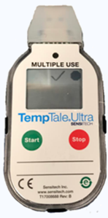
Downloading Reports and Clearing/Reconfiguring TTs
- Immediately stop TT when removed from Vaccine Fridge or Vaccine Bag.
- Insert TT into computer USB port
  - The LED will blink RED while Adobe PDF and TTV data file are being created: DO NOT DISCONNECT while RED
  - When the LED displays solid GREEN, the file generation is complete and are now accessible.
  - A window will automatically open on your computer:
    - If an autoplay box: double click on “Open Folder to view Files”
    - If in Adobe PDF software on computer: double click the PDF icon to open and view PDF file.
    - If TT Manager Desktop (TTMD) Software installed: double click on TTV file icon to open and view file.
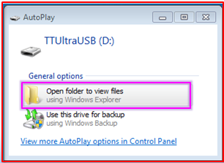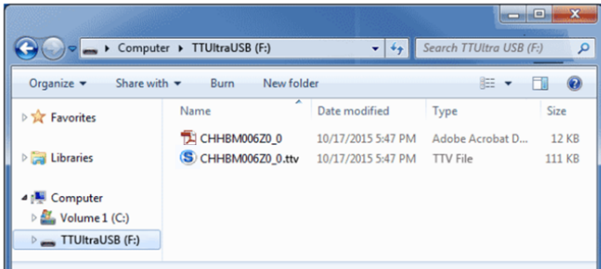
- Save all reports: Reports must be saved for One Year in accordance with Provincial Vaccine Storage and Handling Policy, either:
  - save as digital file on your computer – make sure Date of Report is in title of file.
  - Print off copy of report and place in a binder.
- Clear/Reconfigure TT (see also: Using TempTales – Configuring)
  - Double click TTV file icon to open TT Manager Desktop Software.
  - Step 1: Connect to Monitor: select TT and click “Connect”
  - Step 2: Select Configuration: (should not need to change)
    - verify Measurement Interval time
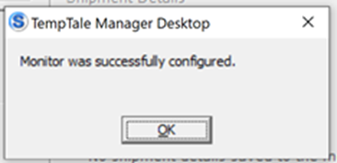
    - verify Start-up Delay
    - verify Low/High Alarm settings
    - Click “Write Configuration”
    - Should receive TTMD box confirmation
  - Clearing/Reconfiguration Completed:
    - option to print report
    - TT monitor screen should now be blank and ready for next use.
  - Close window
  - Place TT in vaccine fridge.

