Using Temptales™ (TT) - Configuring
Steps 3 & 7
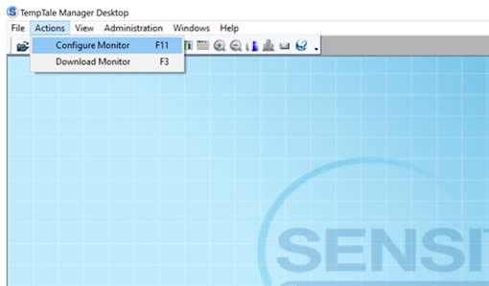
- Insert TT into USB Port
Steps 4 & 8
- Click and Open "TTMD 8.3" application on desktop
- On top left toolbar, click "Actions"
- Click "Download Monitor"
- Select “TempTale”, then click "Start Download"
- Once monitor is finished downloading...
- On top left toolbar, click "Actions"
- Click "Configure Monitor"
Note: Steps 1 – 6 are for initial configuration of a new TT; when clearing, follow step 1, 2 then skip to 7.
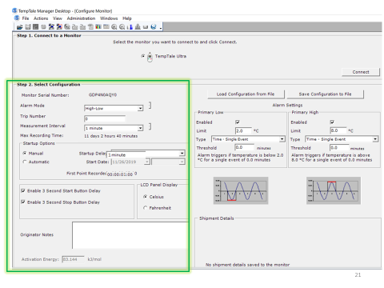
- Step 1: Connect to a Monitor
- Select “TempTale Ultra” then click "Connect"
- Step 2: Select Configuration
- Measurement Interval:
  - 1 minute (routine setting)
  - Max Recording Time: 11 days 2 hours 40 minutes
  - 3 minutes (extended closures)
    - Max Recording Time: 33 days 8 hours
- Startup Options:
  - Click "Manual"
  - Change "Startup Delay" to "1 minute"
See also: “Using a TempTale – Step 2 Recommended Configurations”

- Got to "PDF Options" on bottom left side of screen
- Change Time Zone to "Mountain Time (US & Canada)
- You are all finished!!! Click "Write Configuration"
- Ensure you "Eject" the USB from your computer - then remove the TT from the USB Port

