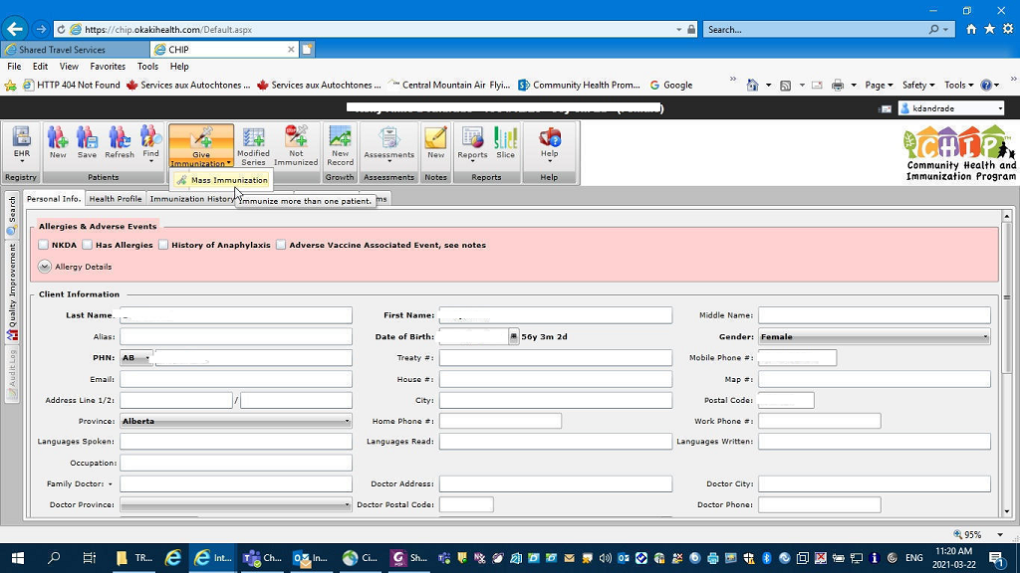
When entering more than one person in a mass vaccination event, find the first person and enter the data required ( such as follow up date as shown on the next page) Once completed, click Mass Immunization
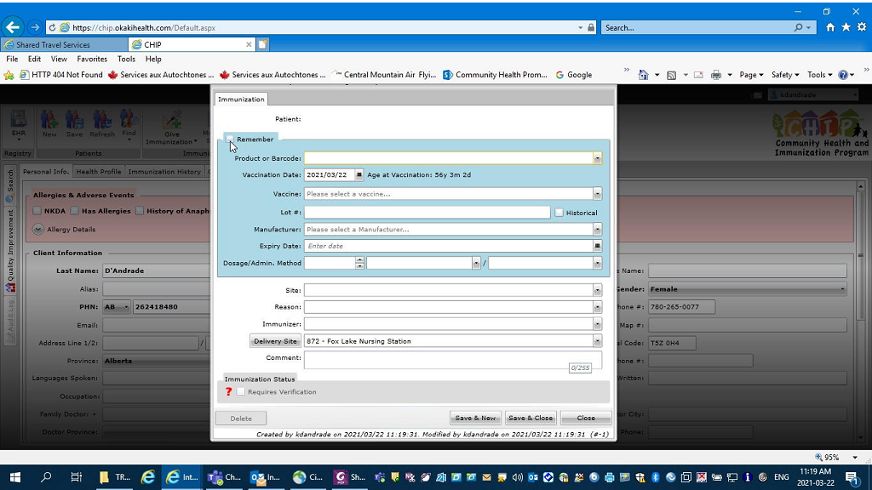
Click Remember in the upper left hand box. Find the vaccine product ( for example: COVID- Moderna )
Fill in all product details including Lot number and expiry date. Then complete the patient information and SAVE and CLOSE.
The next patient that you enter will have the same vaccine information populate. Watch for any communities that are doing multiple vaccinations and change accordingly.

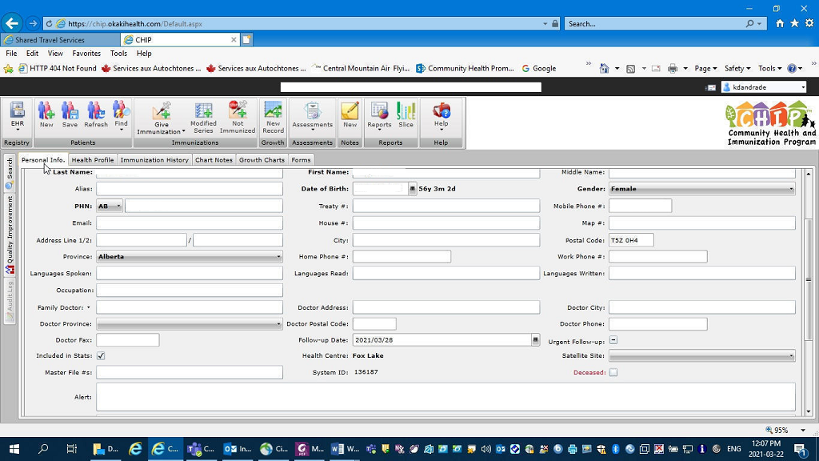
On the personal tab, in order to create a follow up and system tracking, Click on “follow up date”
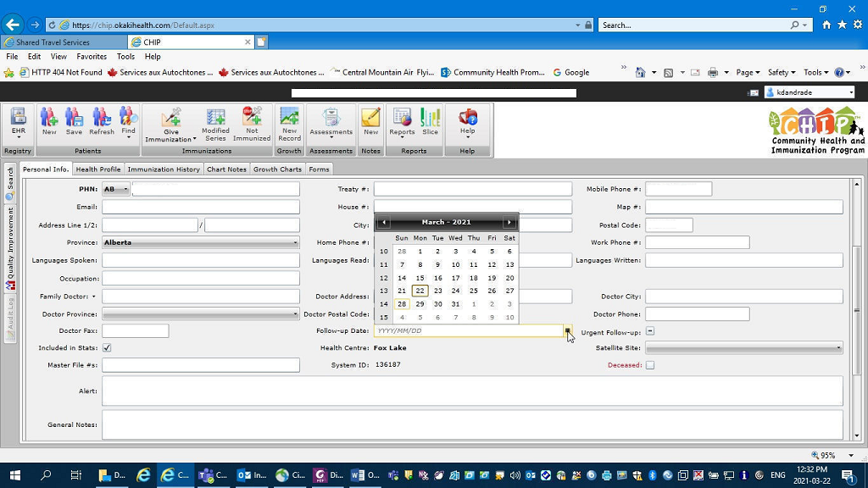
From the calendar, enter the date that is 21 days after the date you are working from, with the date of vaccination being day zero.

